End of chapter quiz

Chapter C1: Air and water

Instructions and answers for teachers
These instructions cover the learner activity section which can be found on page 9. This end of chapter quiz supports OCR GCSE (9-1) Chemistry B, chapter C1.
When distributing the activity section to the learners either as a printed copy or as a Word file you will need to remove the teacher instructions section.

The Activity
This end of chapter quiz comprises of 40 marks covering a range of question types. The quiz starts with some multiple choice questions and then moves on to some short answer questions and then finally on to some longer answer questions.
The question worksheet can be used to consolidate understanding at the end of teaching the chapter, to revisit and refresh knowledge at a later point in the course, or during exam preparation.

Learning Outcomes
This end of chapter quiz relates to the specification learning outcomes in Chapter C1: Air and water. The quiz covers the following topics:
C1.1 How has the Earth’s atmosphere changed over time, and why?
C1.2 Why are there temperature changes in chemical reactions?
C1.3 What is the evidence for climate change, why is it occurring?
C1.4 How can scientists help improve the supply of potable water?
.

Chapter: C1 of J258 - Answers
Total marks: 40
- Most scientists now accept that recent climate change can be explained by increased greenhouse gas emissions.
Which statement best describes the evidence for this? [1 mark]
A | The difference between the consumption of fossil fuels and global temperatures over time.
B | The correlation between the consumption of fossil fuels and global temperature in 2015.
C | A correlation between the consumption of fossil fuels and global temperatures over time.
D | An increase in consumption of fossil fuels and extreme weather.
Your answer
C
2. | The greenhouse effect is causing climate change. Scientists aim to reduce the greenhouse effect by reducing the use of fossil fuels.
 | (a) | How could carbon dioxide be removed from the atmosphere? [1 mark]
Carbon capture✓
Or
Reforestation✓
 | (b) | Why might different countries make different decisions about the best way to reduce climate change? [2 marks]
Personal/ social/ economic (reasons) for example
Developing countries such as China/India will not commit to reducing emissions of carbon dioxide as they are increasing their industry or trying to get their population out of poverty but will increase energy efficiency✓
Whereas the richer, developed countries will commit to reducing carbon dioxide emissions as they have more money to invest in new technologies and have been through their industrial expansion ✓

3. |  | The proportion of greenhouse gases in the Earth’s atmosphere has increased over the last 200 years.
 |  | (a) |  | (i) |  | What is the percentage of carbon dioxide produced from energy generation in the UK? [1 mark]
 |  |  |  |  |  | 37%✓
 |  |  |  | (ii) |  | The amount of carbon dioxide produced has increased in the last 200 years. What could be a reason for the increase? [1 mark]
Any one from:
Increased amounts of concrete for buildings✓
Increased amount of cars/ transport/ vehicles✓
Increased number of homes to heat✓
Increased need for products (so more industry)✓
 |  | (b) |  | What are the potential effects of increased levels of carbon dioxide and methane on the Earth? [2 marks]
Any two from:
Affects where crops can be grown ✓
Extreme weather (patterns) or words to that effect✓
Melting of polar ice caps✓
Flooding of low land✓
 | 4. |  | The global population is increasing meaning there is a greater need for potable water.
 |  |  | (a) |  |  |  | Name two stages of the process used to treat waste water to make it safe for drinking. [2 marks]
Any two from:
Filtration/ membrane filtration✓
Aeration✓
Bacteria✓
Chlorination✓
Distillation✓
 |  |  | (b) |  | (i) |  | How can you test for chlorine? [1 mark]
 |  |  |  |  |  |  | (moist) Blue litmus paper turns red then bleaches✓
 |  |  |  |  | (ii) |  | Chlorine is toxic yet some countries choose to chlorinate their water. Why is this? [2 marks]
The idea that the benefits outweigh the risks:
Used in small amounts so not as toxic ✓
Kills harmful microbes/ bacteria in water so less illness/ spread of disease✓

5. | The Earth, the atmosphere and the ocean are made up of elements and compounds in different states. The particle model can be used to represent of these states.
 | (a) |  | (i) |  | Compare the particle models of each state. [3 marks]
Solid:
Particles are touching
Arranged in a regular pattern
Vibrate around a fixed point✓

Liquid:
Some particles touch
(More) random arrangement
Particles can swap places✓

Gas:
Particles can be separate
Random arrangement
Move in any direction (with more energy)✓
 |  |  | (iI) |  | Why does saltwater and pure water have different boiling points? Use ideas about forces in your answer. [3 marks]
Any three from:
Salt water is a mixture of two types of molecules✓
Water is only made of one type of particle✓
There are intramolecular forces between molecules✓
The intramolecular forces are stronger between particles of salt and water (than water)✓
More energy is required to break the bonds between particles of salt and water than pure water✓
 | (b) |  | (i) |  | How has an oxygen rich atmosphere developed over time? [2 marks]
Plants/algae✓
Carry out photosynthesis producing oxygen and using carbon dioxide so increasing the oxygen in the atmosphere✓
6. |  | There is a high demand for energy in our modern lifestyle. The fossil fuels used for transport and energy generation lead to emissions of pollutants which can harm human health.
 |  | (a) |  | (i) |  | Sulphur dioxide is a pollutant produced by the combustion of fossil fuels. What effect does sulphur dioxide have on the environment? [2 marks]
Any two from:
Formation of acid rain✓
Acidification of lakes/rivers owtte✓
Eroding stonework/ buildings✓
Killing aquatic life/ plants✓

 |  | (ii) | Cars often have catalytic converters. Catalytic converters cause nitrogen oxide to react with carbon monoxide to make carbon dioxide and one other product.
 |  |  | Write a balanced symbol equation for this reaction. [2 marks]
2CO
2NO
N₂
2CO₂
 |  |  | + → +
Correct symbols✓
Correct balancing✓
 | (b) | Catalytic converters are one way of reducing emissions from the combustion of fossil fuels.  Name and describe the effect of two other ways to reduce the emissions of specific pollutants. [4 marks]
Low sulphur petrol ✓
To reduce the amount of sulphur dioxide produced reducing acid rain ✓
Gas scrubbers (in chimneys/ factories) ✓
To decrease emissions and reduce particulates ✓

7. | Combustion is an example of a chemical reaction with fuel and oxygen resulting in new products forming.
 | (a) | (i) | What is activation energy? [1 mark]
 |  |  | The minimum energy required for a reaction to occur
 |  | (ii) | 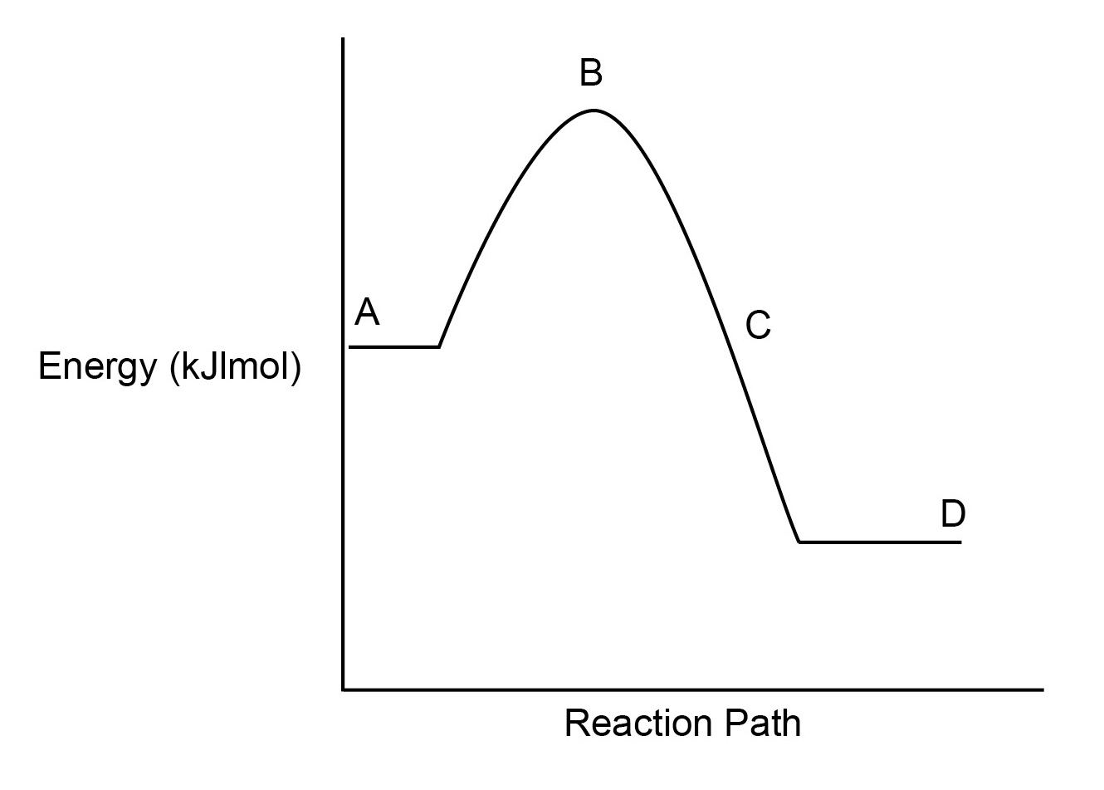
 |  |  | Describe and explain the trend shown in the graph above using scientific knowledge about reactions. [6 marks]
Energy increases between A and B, this is the activation energy needed to start the reaction✓
Energy decreases between A and C because:
Energy needed to break bonds✓
Energy release when bonds are made✓
More energy is released than is used ✓
The products at D have less energy than the reactants at A hence the reaction is exothermic✓
as energy is transferred from the system to the surroundings ✓

 | (b) | (i) | Hydrogen is becoming more commonly used as a fuel.  Complete the balanced symbol equation for the combustion of hydrogen in oxygen. [1 mark]  2  O₂  2  H₂ + → H₂O✓
 |  | (ii) |  | What are the energy changes in the reaction above? Is the reaction endothermic or exothermic? [4 mark]
Bond | Bond Energy (kJ/mol)
H-H | 426
O=O | 495
H-O-H | 920

Energy in:
(2 x 426) + 495= 1347 (kJ/mol) ✓

Energy out:
2 x 920 = 1840 (kJ/mol)✓

Energy change:
1347-1840 = -493(kJ/mol)✓

Answer………………….kJ/mol
Exothermic ✓
This formative assessment resource has been produced as part of our free GCSE teaching and learning support package. All the GCSE teaching and learning resources, including delivery guides, topic exploration packs, lesson elements and more are available on the qualification webpages.
If you are looking for examination practice materials, you can find the Sample Assessment Materials (SAMs) on the qualification webpage: Chemistry B (9–1).

OCR Resources: the small print
OCR’s resources are provided to support the teaching of OCR specifications, but in no way constitute an endorsed teaching method that is required by the Board, and the decision to use them lies with the individual teacher. Whilst every effort is made to ensure the accuracy of the content, OCR cannot be held responsible for any errors or omissions within these resources.
© OCR 2016 - This resource may be freely copied and distributed, as long as the OCR logo and this message remain intact and OCR is acknowledged as the originator of this work.
OCR acknowledges the use of the following content: n/a
Please get in touch if you want to discuss the accessibility of resources we offer to support delivery of our qualifications: resources.feedback@ocr.org.uk
We’d like to know your view on the resources we produce. By clicking on ‘Like’ or ‘Dislike’ you can help us to ensure that our resources work for you. When the email template pops up please add additional comments if you wish and then just click ‘Send’. Thank you.
If you do not currently offer this OCR qualification but would like to do so, please complete the Expression of Interest Form which can be found here: www.ocr.org.uk/expression-of-interest

End of chapter quiz

Chapter C1: Air and water

Learner Activity

Chapter: C1 of J258
Total marks: 42
- Most scientists now accept that recent climate change can be explained by increased greenhouse gas emissions.
Which statement best describes the evidence for this? [1 mark]
A | The difference between the consumption of fossil fuels and global temperatures over time.
B | The correlation between the consumption of fossil fuels and global temperature in 2015.
C | A correlation between the consumption of fossil fuels and global temperatures over time.
D | An increase in consumption of fossil fuels and extreme weather.
Your answer

2. | The greenhouse effect is causing climate change. Scientists aim to reduce the greenhouse effect by reducing the use of fossil fuels.
 | (a) | How could carbon dioxide be removed from the atmosphere? [1 mark]

 | (b) | Why might different countries make different decisions about the best way to reduce climate change? [2 marks]

3. |  | The proportion of greenhouse gases in the Earth’s atmosphere has increased over the last 200 years.
 |  | (a) |  | (i) |  | What is the percentage of carbon dioxide produced from energy generation in the UK? [1 mark]
 |  |  |  | (ii) |  | The amount of carbon dioxide produced has increased in the last 200 years. What could be a reason for the increase? [1 mark]
 |  | (b) |  | What are the potential effects of increased levels of carbon dioxide and methane on the Earth? [2 marks]
 | 4. |  | The global population is increasing meaning there is a greater need for potable water.
 |  |  | (a) |  |  |  | Name two stages of the process used to treat waste water to make it safe for drinking. [2 marks]
 |  |  | (b) |  | (i) |  | How can you test for chlorine? [1 mark]
 |  |  |  |  | (ii) |  | Chlorine is toxic yet some countries choose to chlorinate their water. Why is this? [2 marks]

5. | The Earth, the atmosphere and the ocean are made up of elements and compounds in different states. The particle model can be used to represent of these states.
 | (a) | (i) | Compare the particle models of each state. [3 marks]
Solid:

Liquid:

Gas:

 |  | (ii) | Why does saltwater and pure water have different boiling points? Use ideas about forces in your answer. [3 marks]
 | (b) | (i) | How has an oxygen rich atmosphere developed over time? [2 marks]

6. | There is a high demand for energy in our modern lifestyle. The fossil fuels used for transport and energy generation lead to emissions of pollutants which can harm human health.
 | (a) | (i) | Sulphur dioxide is a pollutant produced by the combustion of fossil fuels. What effect does sulphur dioxide have on the environment? [2 marks]
 |  | (ii) | Cars often have catalytic converters. Catalytic converters cause nitrogen oxide to react with carbon monoxide to make carbon dioxide and one other product.
 |  |  | Write a balanced symbol equation for this reaction. [2 marks]
 |  |  | + → +
 | (b) | Catalytic converters are one way of reducing emissions from the combustion of fossil fuels.  Name and describe the effect of two other ways to reduce the emissions of specific pollutants. [4 marks]

7. | Combustion is an example of a chemical reaction with fuel and oxygen resulting in new products forming.
 | (a) | (i) | What is activation energy? [1 mark]
 |  | (ii)
 |  |  | Describe and explain the trend shown in the graph above using scientific knowledge about reactions. [6 marks]

 | (b) | (i) | Hydrogen is becoming more commonly used as a fuel.  Complete the balanced symbol equation for the combustion of hydrogen in oxygen. [1 mark]  H₂ + → H₂O✓
 |  | (ii) |  | What are the energy changes in the reaction above? Is the reaction endothermic or exothermic? [4 mark]
Bond | Bond Energy (kJ/mol)
H-H | 426
O=O | 495
H-O-H | 920

 |  |  |  | Answer………………….kJ/mol

