The effect of substrate concentration on the rate of an enzyme controlled reaction

Aim
This practical allows you to manipulate apparatus to collect data on the effect of changing the concentration of the substrate, hydrogen peroxide, on a reaction that is controlled by the enzyme catalase. You will be collecting the volume of oxygen produced using an inverted measuring cylinder and the displacement of water.
Time required for activity: 1 hour

Introduction
Enzymes are biological catalysts that speed up metabolic reactions. They are proteins which have a unique shape to them. This enables enzymes to bind to specific substrates at their active site and by putting strain on molecules, lower the activation energy for a reaction to proceed. These reactions can build up molecules, for example polymerising ɑ-glucose to make starch, isomerising molecules, like ɑ-glucose into fructose, or breaking molecules down, like the hydrolysis of starch into maltose.
Catalase is an intracellular enzyme that breaks down hydrogen peroxide (H₂O₂) into water (H₂O) and oxygen (O₂):
2H₂O₂ → 2H₂O + O₂
For an enzyme to speed up a reaction, the substrate needs to collide with the enzyme’s active site to form an enzyme-substrate complex. This relies on kinetic energy and probability. If the enzyme and substrate particles are moving quickly, they are more likely to collide successfully. Similarly, if there are lots of substrate particles present, it is more likely that there will be more successful collisions and the rate of the reaction will be faster.
To investigate this, we can use a range of different concentrations of hydrogen peroxide and measure rate of oxygen production, using a method called gas collection by the displacement of water.

Specification Theory Content Links
Biology A H420: 2.1.4 a; 2.1.4 b; 2.1.4 c; 2.1.4 di; 2.1.4 dii.
Biology B H422: 2.1.3 b; 2.1.3 c; 2.1.4 di; 2.1.4 dii.

Health and Safety
Hydrogen peroxide causes eye irritation, wear eye protection throughout the practical. Care should be taken when cutting the potato with the knife.

Equipment
- 20 vol. hydrogen peroxide
- Distilled water
- 50 cm³ measuring cylinder
- 250 cm³ beakers (×5)
- Eye protection
- Marker pen
- Trough to hold water
- 250 cm³ conical flask
- Delivery tube and bung to fit conical flask
- Cork borer
- Knife
- White tile
- Ruler
- Potato

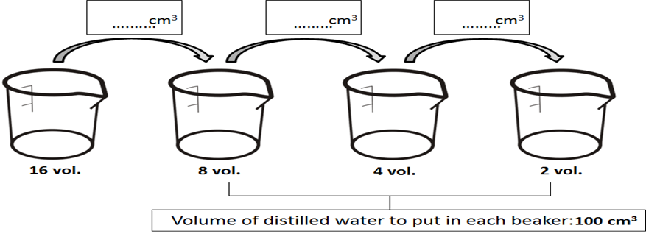
……… cm³
……… cm³
……… cm³
16 vol. 8 vol. 4 vol. 2 vol.
volume of distilled water to put in each beaker: 100 cm^{3.}
Fig. 1 Incomplete diagram showing serial dilutions.

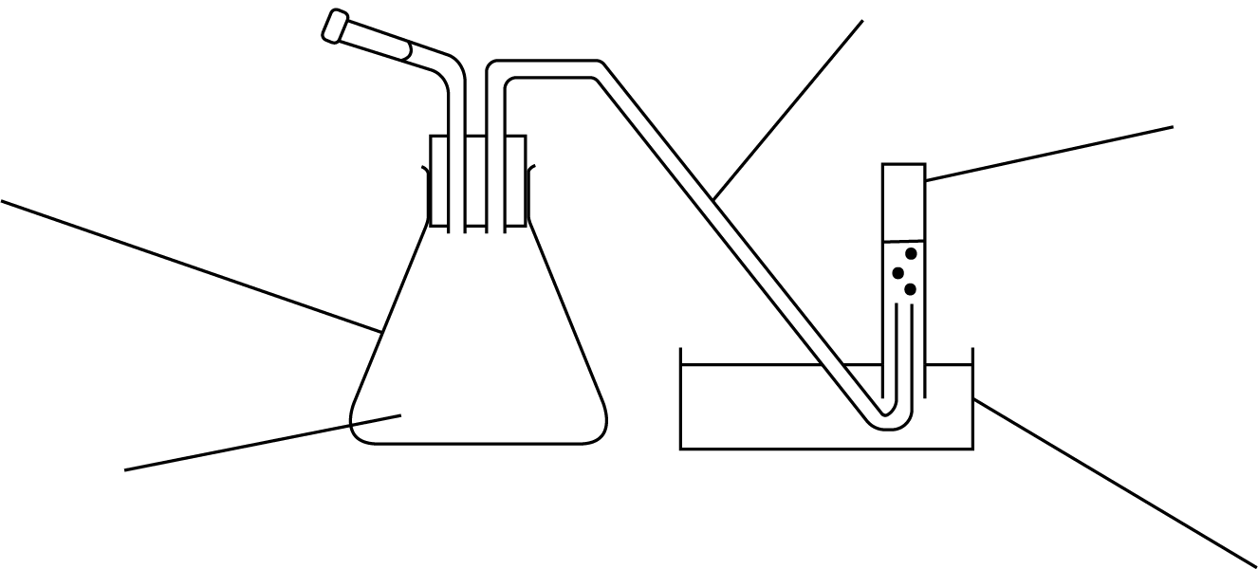
conical flask
delivery tube
measuring cylinder
water trough
catalase source and hydrogen peroxide
Fig. 2 Apparatus set-up for the collection of oxygen by the displacement of water.
Procedure | Understanding
- Label the 250 cm³ beakers:  20 vol., 16 vol., 8 vol., 4 vol. and 2 vol. | What type of molecule is catalase?
- Put 40 cm³ distilled water into the 16 vol. beaker and add 160 cm³ 20 vol. hydrogen peroxide. | What equipment are you using to measure distilled water?  What is the resolution of the equipment you are using?  How can you reduce systematic errors when transferring distilled water into the beakers?
- Now create a dilution series to give you 8, 4 and 2 vol. hydrogen peroxide in the corresponding beakers. Use the diagram in Fig. 1 to help you. | What is serial dilution?  What is the dilution factor for each solution made?
- Put 100 cm³ 20 vol. hydrogen peroxide into the 20 vol. beaker.
- Cut five cylinders of potato using the borer and the white tile. With care, remove any skin from the end of the potato cylinders with the knife. Use a ruler and the knife to cut the cylinders to lengths of exactly 5 cm. | Why is the skin of the potato removed?  What is the resolution of the ruler?  Why is it important to control the surface area of the potato cylinders?
- Set up the apparatus as shown in Fig. 2.  Fill the measuring cylinder with water from the bowl and invert it without lifting the top above the water level of the bowl. | Identify the dependent and independent variables in this investigation.  Why is important to invert the measuring cylinder without lifting the top above the water level?
- Record the starting position of the water in the measuring cylinder in a suitable raw data table. | What type of error would be introduced if not recording the starting position of the water in the measuring cylinder?
- Place one cylinder of potato into the conical flask and get the stopwatch ready. | What would be a suitable control experiment?
- Pour 100 cm³ of 2 vol. concentration of hydrogen peroxide into the flask and, as soon as you can, secure the bung and start the stopwatch. | The reaction is exothermic, what does this mean?
- Record the volume of gas given off every 30 seconds for 3 minutes. | Why is the initial rate of the reaction the fastest?
- Dispose of the contents of the conical flask as directed by your teacher and rinse it under a tap. | What are the limitations of this method?  How can these limitations be overcome?
- Fill the measuring cylinder full of water again.
- Repeat for the other concentrations, moving upwards through the concentrations and using 100 cm³ of solution each time. | What would you expect to happen at very high concentrations?
- Exchange your data with other people so that you have three values for each concentration.
- Calculate the mean and the standard deviation for the volume of gas produced in 3 minutes for each concentration. | What does the standard deviation of a set of results show?
- Calculate the average rate of gas production in cm³ min^{–1} for each concentration of hydrogen peroxide. | Why does the rate of the reaction change during the 3 minutes?
- Draw the most appropriate graphs of the processed results. | What must every line graph have?

Practical skills, apparatus and techniques assessed
a | Reference | Description of skill/technique
 | 1.2.1 (b) | Used conical flasks, delivery tubes, measuring cylinder and beakers safely and without guidance.
 | 1.2.1 (c) | Followed the written instructions without guidance.
 | 1.2.1 (d) | Recorded the volume of oxygen produced for each test.
 | 1.2.1 (e) | Recorded the volume of oxygen for each test, the mean volume of oxygen and the standard deviation for each concentration in a table.  Produced a line graph of the mean volume of oxygen produced against concentration of hydrogen peroxide, including error bars.
 | 1.2.1 (f) | Followed conventions in producing a suitable table and graph for the results and processed data.
 | 1.2.1 (j) | Collected oxygen using the displacement of water without guidance.

Further Investigations and Extension Questions
The effects of pH, temperature and non-competitive inhibition can be investigated using the same experimental set-up. When investigating pH or non-competitive inhibition, the potato cylinders should be given time to equilibrate in each solution before the addition of hydrogen peroxide.
- What is the word equation for the reaction controlled by catalase?
- Give one reason why it was important to keep all cylinders the same size?
- Explain the shape of the graph you have drawn using biological ideas and relevant enzyme theory.
- (a) State two limitations of the experiment.
- State ways to overcome the limitations you have mentioned in (a).

Scientific and Practical Understanding
Enzymes are globular proteins that speed up metabolic reactions and lower the activation energy required for a reaction. They have unique active sites that bind to specific molecules meaning that they can only do certain reactions, creating an enzyme-substrate complex. This is formed when a substrate molecule successfully collides with the enzyme’s active site. This will allow the reaction to happen and form the products.
A product of a reaction is the substance that is made from the reactants. Products are released from an enzyme’s active site, allowing the active site to bind to another substrate molecule and carry out another reaction.
The enzyme catalase is found in plant and animal cells. It catalyses the breakdown of hydrogen peroxide into water and oxygen.
catalase
hydrogen peroxide water + oxygen
catalase
2H₂O₂ H₂O + O₂

The reaction can happen at room temperature, but it is much faster in the presence of catalase. Catalase is found throughout nature, protecting cells from the damage that hydrogen peroxide can cause. Due to this phenomenon, we can use different tissues to study the effects of hydrogen peroxide concentration on the rate of oxygen production by catalase, such as potato.
The rate of a reaction is how quickly it happens. When you calculate rate, you are reducing the measured values to a unit of time, for example how much oxygen is produced in one minute. To calculate the rate in this investigation, the volume of oxygen (cm³) is divided by the time taken (s or min), the unit for this rate could be cm³ s^{–1}or cm³ min^{–1}.
Random and systematic errors reduce the accuracy of a measurement. An accurate measurement is close to the true value.
Random errors are caused by uncontrollable differences between tests. They reduce precision. An example of a random error in this investigation might be changes to the room temperature, or differences between the catalase concentrations in each potato cylinder. Another example of random error might be the temperature of hydrogen peroxide. Hydrogen peroxide should be stored in a refrigerator, but it is best to allow it to reach room temperature before the experiment so this will not be a factor in slowing down the rate of reaction. Hydrogen peroxide naturally decomposes so new and old batches will give different results.
A systematic error changes by the same amount each time. It may be caused by a piece of equipment not being calibrated before being used to measure a variable.
A control experiment is used to compare the data against to show that it was the effect of the independent variable causing the change in the dependent variable. For enzyme investigations, boiled enzymes are frequently used to show that without a functional enzyme the change in different factors, such as substrate concentration, will not cause a change in the dependent variable.

Notes and References
Health and safety should always be considered by a centre before undertaking any practical work. A full risk assessment of any activity should be undertaken including checking the CLEAPSS website.
CLEAPSS

