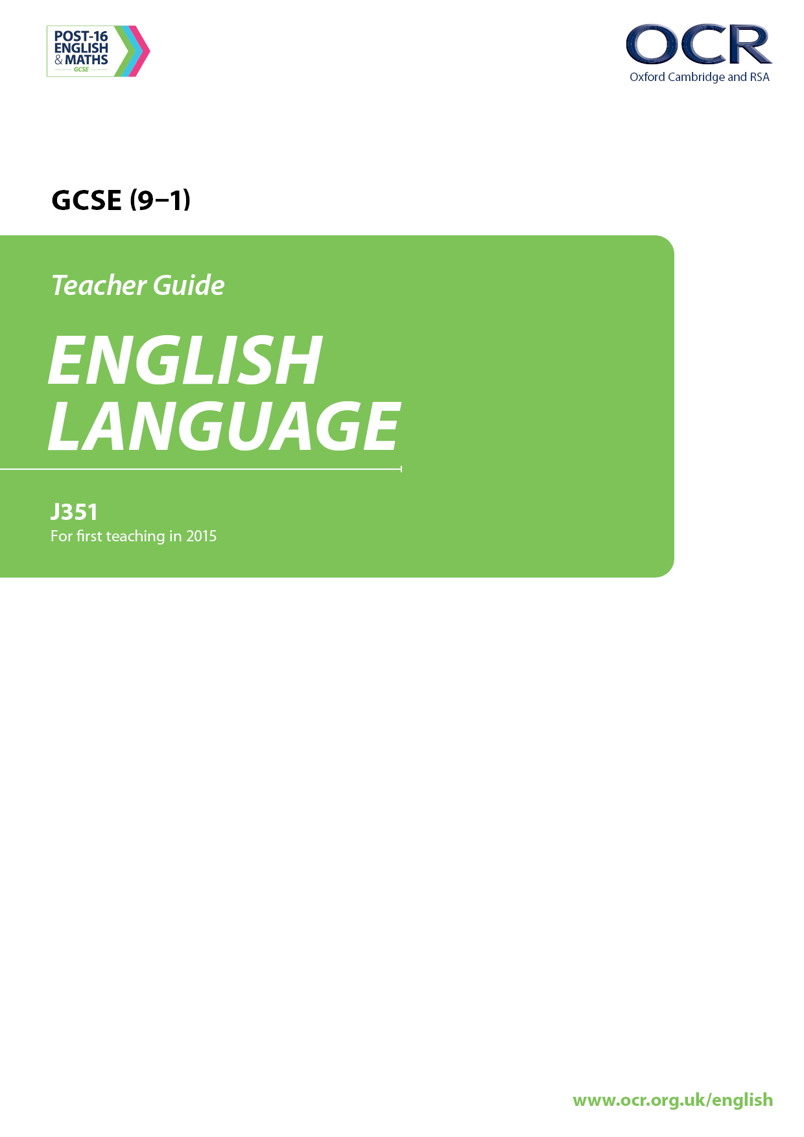
Delivery guide – Component 2
Exploring effects and impact
Version 1

Contents

Introduction 3
Curriculum Content 3
Thinking Conceptually 4
Introduction: The Student Profile 4
Introduction to Literary Texts 4
Thinking Contextually 6
Reading Skills 6
Writing Skills 6
Activity: Developing confidence in reading different texts 7
Developing confidence in reading different texts: Extension activity – Exam practice 8
Activity: Exploring characterisation 8
Exploring characterisation: Extension activity – Exam practice 8
Activity: Exploring writers’ ideas 8
Activity: Exploring setting 9
Exploring setting – Extension activity 9
Activity: Exploring themes 9
Activity: Narrative viewpoint 10
Narrative viewpoint – Extension activity 10
Activity: Supporting accuracy 10
Activity: Editing/Re-drafting skills 11
Activity: Wider reading to help boost literacy 12

Introduction

Delivery guides are designed to represent a body of knowledge about teaching a particular topic and contain:
- Curriculum content: a clear outline of the content covered by the delivery guide;
- Thinking Conceptually: expert guidance on the key concepts involved, common difficulties students may have, approaches to teaching that can help students understand these concepts and how this topic links conceptually to other areas of the subject;
- Thinking Contextually: a range of suggested teaching activities using a variety of themes so that different activities can be selected that best suit particular classes, learning styles or teaching approaches.

Curriculum Content

In Component 2: Exploring effects and impact, students read and respond to unseen prose fiction or literary non-fiction texts taken from the 20th and/or 21st century. This may include, for example, extracts from novels, short stories or literary non-fiction such as autobiography.

This guide focuses on developing the skills to:
- identify the main themes and ideas in texts; interpret meanings and effects across more than one text
- comment on the impact on writers’ use of language and structure on the reader; analyse and compare writers’ use of language, paying attention to detail
- explore connections across texts to develop an understanding of the ideas, values and attitudes presented in them
- draw inferences and justify points of view by referring closely to evidence from the texts.

Students will also produce one piece of original creative writing. They should try to use their understanding of different texts types, forms, linguistic and structural effects, gained from reading a variety of texts, to inform their own language choices and techniques.

This guide focuses on developing the skills to:
- maintain a consistent viewpoint across a piece of writing, making conscious decisions, for example, about narrative point of view
- make considered choices of vocabulary and grammar to create deliberate effects
- use the knowledge gained from wide reading of prose fiction and literary non-fiction to inform language choices and techniques
- use language creatively and imaginatively adapt tone, style and register as appropriate
- use a range of sentence structures for clarity, purpose and effect, with accurate punctuation and spelling.

Thinking Conceptually

Introduction: The Student Profile

This delivery guide has been created specifically to support the delivery of GCSE (9-1) English Language J351 Component 2 for post-16 students. The challenges and opportunities that the teaching of this specific cohort presents have been outlined in the Component 1 delivery guide. However, it is worth pointing out that just as preparation for Component 1 can benefit from students’ relative maturity and breadth of experiences, in terms of Component 2, too, these advantages and their implications can be effectively harnessed; as well as being of benefit in relation to reading, these students’ greater maturity and their wider range of real-world experiences can and should feed into their imaginative work in the writing section of the paper.

Post-16 students are likely, at least collectively, to have encountered a wider range of literature than their younger peers, and may therefore have a slightly wider range of reference within which to place new texts they are offered. This will also mean that they have been exposed to a wider variety of writing styles. The fact that teaching groups may well contain students from different centres, will lead to diversity of shared experience which is not present to the same extent within the 11-16 context. As the content of Component 2 is based on understanding and engaging with a range of prose fiction and literary non-fiction texts, all previous experience will come into play.

NB. When we talk of texts in this context, we refer to extracts as opposed to whole novels – there is no issue with delivering whole novels to students, but given the one-year delivery timeframe, students may better benefit from studying a wide range of extracts – for this specification, the greater the range and variety of texts a student encounters, the better.

Secondly, the subject matter with which these students can engage may be slightly more sophisticated; themes such as oppression and power within personal and political contexts, for example, are likely to resonate slightly more with them because of their wider life experience. This can, again, be helpful for teaching purposes. Travel and experiences of other cultures may well be more prominent for some post-16 students; this can also lend itself to a more thoughtful reception of diverse texts. With encouragement, they will also be able to bring their greater maturity to bear on their imaginative/expressive output, resisting some of the temptations of younger students to hyperbolise, and being more able than their younger peers to adopt a critically-constructive perspective of their own work. Technically as well as in terms of narrative content and style, they could become more critical readers of their own creative work, and they may therefore be more receptive to engaging with and exploring suggestions about ways of improving it, perhaps feeling more motivated to do so than their younger peers.

Introduction to Literary Texts

As with the Component 1 delivery guide, this guide has been designed to address some of the challenges and to recognise the opportunities that the distinctive student profile of this cohort presents.

The structural parity between the two exam papers was mentioned in the guide for Component 1; this will support students by giving them experience in the process of identifying ideas, analysing language and comparing and critically evaluating texts, which is common to both papers. Whereas Component 1 perhaps lends itself to that of the real world, Component 2 relates to the literary and to the imaginative; for some students this will be a major source of its appeal.

Although the qualification has been designed to stand alone, links could potentially be made with GCSE Literature, which students may have taken previously or may be re-sitting. These links would, clearly, benefit students with regard to both specifications.

All unseen texts in the exam will be include contextual information (given as an introduction in italics), to give students a framework within which to place the extract. At an average of 350-650 words, these unseen texts are likely to be drawn from longer texts, making it possible for centres to create practice assessment activities quite easily with varying amounts of scaffolding, in order to build confidence and enable students to appreciate the importance of the contextual information provided. The Student Resources accompanying this Delivery Guide are designed to help support teachers in providing practice assessment activities. Contextual information is provided separately and can be utilised in a variety of ways.

Although this English Language specification does not require students to read whole novels, there is no reason why whole texts cannot be used as a basis for some of the exam preparation. In order to better support students, it may be useful to begin exploration of texts using those with which they are already familiar, i.e. getting them to revisit books retrospectively so that they can practise the process, moving then onto unfamiliar texts, with incrementally reducing degrees of scaffolding. The more familiar students can become with a range of different texts, the more confident they will be in responding to unseen texts in the exam.

Thinking Contextually

This delivery guide supports the development of both reading and writing skills.

Reading Skills

The Learner Resources help students to engage with 12 extracts in detail and support them in developing close analysis skills.

These Learner Resources are based on four elements which are important in developing students’ understanding of prose fiction texts:
- Character/characterisation
- Setting
- Themes
- Narrative viewpoint

Each pack of Learner Resources is made up of a prompt sheet followed by three sample extracts where one of the above elements of the writing is particularly significant.

Writing Skills

The focus of the writing task in Component 2 will be on imaginative and creative writing. The process of studying a range of literary texts and focusing on the writer’s craft will, in turn, help to increase student awareness of their own creative work. Techniques that are evident in the texts studied could, potentially, become subjects for their own experimentation and practice. The extracts provided in Learner Resource 1 could be revisited with this in mind, and used as a springboard to practise student writing skills.

Students will need to answer one creative writing task from a choice of two:
- The task is connected to the reading theme
- The task may include:
- narrative writing
- descriptive writing
- autobiographical writing
- Bullet points will be provided for support
- Students are assessed on their use of a range of vocabulary and sentence structures, with accurate spelling and punctuation
- Presentational/visual features are not assessed.

The choice of two writing tasks, mirroring the format of Component 1, provides some flexibility, and there is plenty of scope for students who do (or do not) wish to embrace the challenge of producing a fictional piece in exam conditions to do themselves justice. A really important aspect of preparation will be to teach students how to scan and assess the relative merits (in terms of their own strengths and weaknesses) of each of the writing questions, in order to select the one which will enable themselves to demonstrate their strengths and abilities most effectively. For some students this may be a very clear-cut decision; for many it will depend on the topics/formats set in each specific exam. One opportunity for this cohort during their post-16 course may be to gain practice and confidence in a genre of writing they have previously found to be challenging, so that they have a genuine choice between the two questions in this section of the exam.

The activities in this guide aim to support students with their written accuracy.

Activity: Developing confidence in reading different texts

Extract based activity to introduce learners to a variety of prose fiction texts.

Ask students to find an extract of appropriate length in a literary text they have studied previously (in many groups this may generate a range of texts but even if it does not they can still choose different extracts on which to focus). You may want to begin with extracts which are comparable to the length of those given in the exam – 350-650 words – or you may decide to start with shorter extracts and build up from there.

Students work in groups to talk their classmates through their chosen texts. They could use the following bullet points as a guide and add some more of their own ideas. Students discuss:
- When the text was written and when it is set
- The identity of the narrator/their relationship to the material they are narrating
- The situation/s being described
- Any dialogue included, and what it relates to
- Tone/mood/atmosphere
- Themes/ideas
- Any particularly distinctive features that are evident
- Any ideas they have on the writer’s attitude towards ideas/ themes in the text.

Texts that may be useful as a starting point for this activity are:
Heroes – Robert Cormier
Riding the Black Cockatoo – John Danalis
My Family and Other Animals – Gerald Durrell
Lord of the Flies – William Golding
The Curious Incident of the Dog in the Night-time – Mark Haddon
To Kill a Mockingbird – Harper Lee
Animal Farm – George Orwell
Nineteen Eighty-Four – George Orwell
Rani and Sukh – Bali Rai
Balzac and the Little Chinese Seamstress – Dai Sijie
Touching the Void – Joe Simpson
Of Mice and Men – John Steinbeck
Anita and Me – Meera Syal
Roll of Thunder, Hear my Cry – Mildred Taylor
Felicia’s Journey – William Trevor
Talking in Whispers – James Watson

Extracts from 12 of the texts in this list are given in Learner Resource 1 and can be used by students for this activity. Learner Resource 2 provides short contextual descriptions for each of the 12 texts. Once students have discussed their extract(s) they can try to match the contextual description to the text.

Alternatively, students could work in groups to read through the 12 extracts in Learner Resource 1 and group the extracts in a range of different ways so that they develop an overview of the temporal/thematic/stylistic differences of a variety of texts. For example, texts could be grouped according to themes, country of origin, narrative viewpoint (first/third person), setting (temporal or locational) or content.

Developing confidence in reading different texts: Extension activity – Exam practice

Exam practice using the Component 2 Sample Assessment Materials.

Students turn their texts into mini practice tests by combining their chosen extract with some exam style questions, taken from the Sample Assessment Materials.

This activity is best delivered at a later stage in the course once students have had a chance to develop their skills and have gained a better understanding of the exam question requirements. Some students could have a go at creating the indicative content section of a brief mark scheme, to be used in conjunction with the generic skills/levels descriptors. It would probably be best to start by looking at one specific question, again, drawing on the materials available online to gain as sense of what is being aimed at in terms of content and tone.

Component 2 – Sample assessment materials
http://ocr.org.uk/Images/169264-unit-j351-02-exploring-effects-and-impact-sample-assessment-material.pdf

Activity: Exploring characterisation

This activity introduces learners to different elements of characterisation in a range of prose fiction texts.

Use Learner Resource 3.0 to introduce students to the different elements of characterisation. Students add ideas under the headings in the hexagons and include relevant quotations from the subsequent extract(s), Learner Resources 3.1, 3.2 and 3.3.

The first extract could be looked at and discussed in class, the second in pairs, and the third tackled by students individually.

Exploring characterisation: Extension activity – Exam practice

Students tackle comparison questions based on the extracts Learner Resources 3.1, 3.2 and 3.3.

NB It is worth remembering that literary non-fiction could be explored as well as prose fiction.

The three extracts can also be used intermittently at different times throughout the course as a revision tool, particularly when students are reasonably confident and familiar with the assessment requirements.

Activity: Exploring writers’ ideas

This activity supports the preparation for Question 4, identifying a range of ideas that students can then match to sources. Rather than starting with texts and then identifying the key ideas within them, Learner Resource 4.0 presents students with a selection of ideas, and their task is to find texts in which these ideas are particularly prominent. This activity could be presented in the form of a competition (if this would be compatible with student and teacher preferences). Another option would be for groups to be designated to find a collection of texts linked to one of the ideas. Some of these texts could then, in turn, be used for teaching resources; meanwhile, the process of reading a series of texts in order to identify ideas rather than content makes the activity potentially useful as preparation for Question 4.

Activity: Exploring setting

This activity supports learners in exploring ‘setting’ in a range of prose fiction texts.

Introduce the activity by presenting students with a world map. Ask students to mark on the map the geographical setting of as many books that they have read as possible, and then to display/compare these. Pick a few examples to explore in more detail. Encourage students to think about how the geographical setting can affect our reading and of a text.

The same can be applied to temporal setting by using a timeline which plots significant historical and cultural events. Students plot the temporal settings of the texts they have read onto this timeline and discuss how historical and cultural events at the time may affect our understanding of the text.

Use Learner Resource 4.0 to introduce students to the impact that setting may have on our reading of a text. Students add ideas under the headings in the hexagons and include relevant quotations from the subsequent extract(s), Learner Resources 4.1, 4.2 and 4.3.

It is important that students can distinguish the difference between the setting of a text and the writer’s own setting - the time and place in which the writer was writing the text, and the when and where the narrative is set, is often quite different. The above approaches can also be used to establish the writer’s own context.

Exploring setting – Extension activity

This activity could easily be extended through use of further extracts of the students’/ teacher’s choice in which the presentation of a setting is highlighted. Examples would be:
- parts of the first/final chapters of Of Mice and Men
- the fifth paragraph of Chapter One of Touching the Void
- the first paragraph of Chapter Two of My Family and Other Animals.

Use Learner Resources 4.0, 4.1, 4.2 and 4.3

Activity: Exploring themes

This activity introduces learners to the significance of theme in a range of prose fiction texts.

As an introduction activity, students could create a Prezi presentation which they can add to during the course, showing the range of themes that they have encountered in their reading so far. This could be used for revision at the end of the course.

This could entail identifying one major theme per text but then using the zoom facility to break the text up into a fuller range of themes, and to examine the connections between them.

Use Learner Resource 5.0 to remind students of the significance of theme. Students add ideas under the headings in the hexagons and include relevant quotations from the subsequent extract(s), Learner Resources 5.1, 5.2 and 5.3.

As a paired speaking and listening activity, students could discuss and rank order the importance of themes within a particular text (potentially they could also do this with characters). The criteria for placing a specific theme high/low on the list could be decide in their pairs, or could be discussed in class as a way into the activity.

Activity: Narrative viewpoint

This activity supports learners in exploring the narrative viewpoint of a range of prose fiction texts.

Each of the extracts chosen for this activity are first person narrative, but each of the characters has a different relationship with:
a) the reader
b) the material they are describing
c) themselves.

The accompanying worksheet (Learner Resource 6.0) has been designed to help students engage with each of these aspects of the presentation of the narrator, and to draw out elements of this so that they are more explicit.

Once students have done this for one or more of the extract, they can have a go at rewriting the passage from another character’s perspective, and/or turning it into a third person account.

Narrative viewpoint – Extension activity

Students find extracts of similar length to those in Learner Resources 6.1, 6.2 and 6.3 which feature third person narrators, and examine them in light of the bullet points listed below.
- When the text was written and when it is set
- The identity of the narrator/their relationship to the material they are narrating
- The situation/s being described
- Any dialogue included, and what it relates to
- Tone/mood/atmosphere
- Themes/ideas
- Any particularly distinctive features that are evident
- Any ideas they have on the writer’s attitude towards ideas/ themes in the text.

What differences/similarities do they find between the texts?

Alternatively, other extracts in Learner Resource 1 could be re-used for this purpose.

Activity: Supporting accuracy

Learners produce a guide to help them to focus on and improve the technical accuracy of their writing.

Accuracy is an important feature of students’ writing in the exam. Spelling, punctuation and sentence structure carry a total of 16 marks, and partly for that reason but also in terms of life skills for the world beyond, students will need to work systematically to improve the accuracy of their written work. This activity will support the development of accuracy in this area.

Get students to produce a selection of online guides for younger students (or another group of the teacher’s choosing) about a range of topics to do with grammar, accuracy and punctuation. Topic choices could be organised in several different ways, for example they could:
- link with self-assessment activities identifying students’ weaknesses in these areas
- be teacher-selected based on knowledge of student weaknesses
- be organised so that a complete set is produced across the class
- be staged, so that students produce basic guides at the start of the course and then a second round, for more sophisticated topics, later on.

Possible topics might be:
- What is a sentence?
- Semi-colon use
- How to use speech marks
- Different kinds of conjunctions.

Students can include hyperlinks to further resources/linked quizlets etc. The process of finding these and practising on them will help support/develop students’ own knowledge and skills, and may generate access to a range of useful sites that can be incorporated into future teaching. As well as focusing on accuracy individually, this activity will mean that centres build up a bank of resources that can be used and/or provided as examples for future cohorts.

Guidance on approaching this task, together with an example of what students are aiming for, has been provided in Learner Resources 7.0 and 7.1.

Activity: Editing/Re-drafting skills

The activity highlights to learners the importance of checking and editing their written work.

This is an aspect of the writing task that can prove to be quite challenging, especially for students who may be struggling to develop their ideas in sufficient detail or for those who do not feel confident about the writing they produce. Arguably the best role model here is likely to be the teacher; the more access students can be given to the process of writing, and to the series of choices that effective writing requires, the more able they are likely to be to reflect critically on the crafting of their own work.

In this activity, students produce a piece of writing based on one of the writing tasks in the Sample Assessment Material, or a similar task set by the teacher.

They should edit it as effectively as they are able to while it is in handwritten version, and then, ideally, type it up for the next stage of the activity. At that point they can note any errors revealed by spelling/grammar check and correct them if that is felt to be useful.

Using their text as a basis, students should then read their work, identifying different sentence lengths and highlighting them using different colours. This will reveal instantly, in a way that is visually clear, the extent to which they have varied their sentence lengths within their writing.

The same base text can be used in a similar way to check the following:
- Sentence type (simple/compound/complex/minor)
- Sentence function (interrogative/declarative/imperative/exclamatory)
- Use/overuse of hyperbole
- Use/overuse of figurative language
- Consistency of register/tense/person
- The presence of structural/cohesive devices.

As another way of addressing their precision of word choice, students could focus, for example, on adjective use, arranging a selection of adjectives identified by students, found in a thesaurus, or supplied by the teacher, along a continuum – see Learner Resource 8.

The same activity could be applied to other parts of language, such as noun use, to enable students to consider the effect of particular word choices - see Learner Resource 8.

Activity: Wider reading to help boost literacy

Learner Resource 9 provides suggestions for extending students’ wider reading.

We’d like to know your view on the resources we produce. Click ‘Like’ or ‘Dislike’ to send us an auto generated email about this resource. Add comments if you want to. Let us know how we can improve this resource or what else you need. Your email will not be used or shared for any marketing purposes.

Looking for another resource? There is now a quick and easy search tool to help find free resources for your qualification.

Resources: the small print
OCR provides resources to help you deliver our qualifications. These resources do not represent any particular teaching method we expect you to use. We update our resources regularly and aim to make sure content is accurate but please check the OCR website so that you have the most up to date version. OCR cannot be held responsible for any errors or omissions in these resources.
Though we make every effort to check our resources, there may be contradictions between published support and the specification, so it is important that you always use information in the latest specification. We indicate any specification changes within the document itself, change the version number and provide a summary of the changes. If you do notice a discrepancy between the specification and a resource, please contact us.
© OCR 2020 - You can copy and distribute this resource freely if you keep the OCR logo and this small print intact and you acknowledge OCR as the originator of the resource.
OCR acknowledges the use of the following content: N/A
Whether you already offer OCR qualifications, are new to OCR or are thinking about switching, you can request more information using our Expression of Interest form.
Please get in touch if you want to discuss the accessibility of resources we offer to support you in delivering our qualifications.

