Lesson element 8.04a Properties of a triangle
Below are 15 different descriptions of lines or coordinates that might form triangles.

Cut up all of the below into 15 individual cards and give them to students.

Can students identify which of these are triangles and which ones are not?

Can students identify which of the triangles are right-angled triangles and which ones are not?

Not drawn to scale  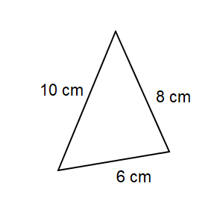 | Not drawn to scale  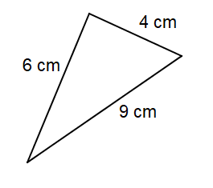 | Lengths of sides:  7 cm  24 cm  25 cm
Not drawn to scale  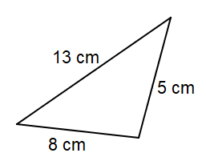 | Not drawn to scale  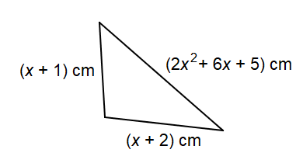 | Lengths of sides:  7 mm  9 mm  11 mm
Lengths of sides:  37 cm  11 cm  35 cm | Lengths of sides:  5 cm  4 cm  10 cm | Vertices:  (1, 2)  (1, 5)  (5, 5)
Vertices:  (3, 1)  (5, 3)  (0, 4) | Vertices:  (1, 1)  (3, 2)  (3, 6) | Vertices:  (1, 2)  (3, 0)  (3, 4)
Vertices:  (1, 0)  (-1, 0)  (-1, 4) | Lengths of sides:  9 m  40 m  42 cm | Lengths of sides:  15 cm  8 cm  17 cm

