# GCSE (9-1) Physics A & B

# AS and A Level Physics A & B

## Language of Measurement in context

### The purpose of this exemplar investigation is to illustrate the use of the language of measurement terms in the context of a Physics practical activity. Measurement terms in bold are defined further in the glossary.

### The balancing of a rod

This resource is adapted from one of the GCE legacy practical tasks available on OCR interchange.1

In this experiment, a student investigates the balance of a metal rod to determine a value

for the mass *M* of the rod.

The experimental set up is shown in **Fig. 1**.

loop of string

resting in

the gap

between

the tapes

*l*

jaws of a

clamp

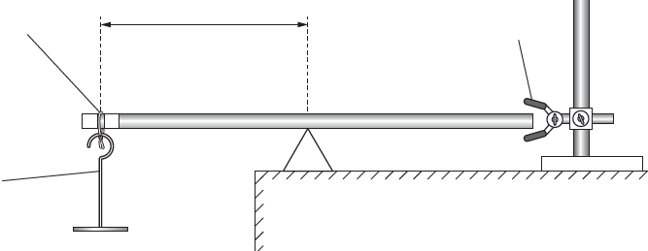

mass *m*

pivot

metal rod

tape

**Fig. 1**

The distance *l* when the rod is balanced is measured from the loop of string to the pivot as the mass *m* suspended from the rod is varied.

The student makes a mistake when taking the measurement of *l* as shown in **Fig. 2**.

rod

loop of

string

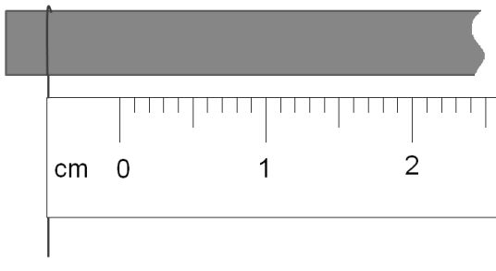

Here a **systematic error** has been introduced when measuring the length *l* with a ruler. The student has not measured from the loop of string using the zero mark on the ruler.

**Random error** is always present in a measurement. Calculating the mean for repeat measurements can reduce the effect of random error.

ruler

**Fig. 2**

The student now measures distance *l* correctly from the loop to the pivot, as shown in **Fig. 3**.

The distance measured is 22.1cm or 0.221m.

When using apparatus with an analogue graduated scale, the absolute **uncertainty** in a single measurement is typically taken to be ± half the smallest graduation, in this case ±0.5mm.

The overall absolute uncertainty in any distance measured with a ruler involves two measurements.

overall absolute uncertainty = 2 × 0.5mm = ±1mm. 2

**distance *l* = 0.221 ± 0.001m**

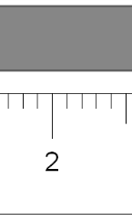

*l*

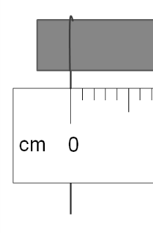

22

**Fig. 3**

In this experiment there are other factors that can contribute to uncertainty in the measured value of *l* other than the uncertainty associated with the ruler scale.

For each value of *m*, the measurement of *l* is taken three times and the mean length *l*ave and the value of(1/*l*ave)is calculated. The results are in the table.

Mass *m* is the **independent variable**. Length *l* is the **dependent variable**. In general, the independent variable would be recorded in the first column, then the dependent variable to the right and processed data to the far right

|  |  |  |  |  |  |
| --- | --- | --- | --- | --- | --- |
| ***m*/kg** | ***l*1 /m** | ***l*2 /m** | ***l*3 /m** | *l*ave /m | (1/*l*ave)/m–1 |
| 0.100 | 0.263 | 0.260 | 0.259 | 0.261 | 3.84 |
| 0.150 | 0.248 | 0.249 | 0.251 | 0.249 | 4.01 |
| 0.200 | 0.236 | 0.233 | 0.232 | 0.234 | 4.28 |
| 0.250 | 0.219 | 0.220 | 0.223 | 0.221 | 4.53 |
| 0.350 | **0.196** | 0.198 | **0.236** | 0.197 | 5.08 |

The length measurements are given to the nearest mm. 1mm is the **resolution** of a standard 30cm ruler.

An **anomalous result** **(outlier)** is identified here. The measurement can be repeated or excluded from the calculation of the mean length.

The repeated measurements of *l* are frequently close together for each value of *m.* We can say the **precision** of the measurements is good although there is some variation.

The measurements of *l* by the student here for each value of *m* are produced under similar conditions by the same student and are closely clustered. We can say the measurements have good **repeatability**.

|  |  |  |  |
| --- | --- | --- | --- |
| m/kg | *l*1 /m | *l*2 /m | *l*3 /m |
| 0.150 | 0.248 | 0.249 | 0.251 |

The **range** of values of *l* for each value of *m* is also an indication of the **uncertainty** in the measurement which takes in to account other factors than just the uncertainty associated with the ruler scale.

The student plots a graph of *m* (*y*-axis)against $\frac{\text{1}}{\text{l}}$ (*x*-axis) and draws a **line of best fit**.

His teacher says the intercept of the line with the *y*-axis can be used to determine a value for the mass *M* of the rod.

The student determines an experimental value for the mass *M* of the rod.

***M = 0.648 kg***

The mass of the rod when measured on an electronic balance is 0.626kg. This is the true value for the mass of the rod (note: this assumes that the balance is both accurate and calibrated).

Does the student’s experiment give an **accurate** value for the mass of the rod?

percentage difference = $\frac{\text{experimental value} \text{–} \text{true value}}{\text{true value}}$ × 100

= $\frac{\text{0.648 kg} \text{-} \text{0.626 kg}}{\text{0.626 kg}}$ × 100 = 3.51 %

A measurement result is considered **accurate** if it is close to the true/accepted value.

The percentage difference between the student’s experimental result and the true/accepted value for the mass of the rod is only 3.51%.

The student concludes that the value for the experimental value of the mass of the rod is **accurate** because its value is close enough to the true/accepted value of the mass of the rod**.**

The student’s teacher carried out the experiment at home with their own apparatus. The teacher found that the value of their experimental value for the mass of the rod differed by 14.6% from the true value.

A measurement result is considered **reproducible** if similar results are obtained using different groups, methods or equipment. Here we can say that the measurement results do **not** have good reproducibility (based on only two experiments).

*Notes*

1 This resource is in the style of a GCE practical but many of the terms apply to both GCE and GCSE. The specification defines the content of the assessments.

2 We are aware that some textbooks do not give a consistent message regarding the treatment of uncertainties associated with measuring instruments. For GCE Physics A and Physics B we will therefore allow both half the resolution as the absolute uncertainty for a measuring instrument and the resolution itself as the absolute uncertainty.

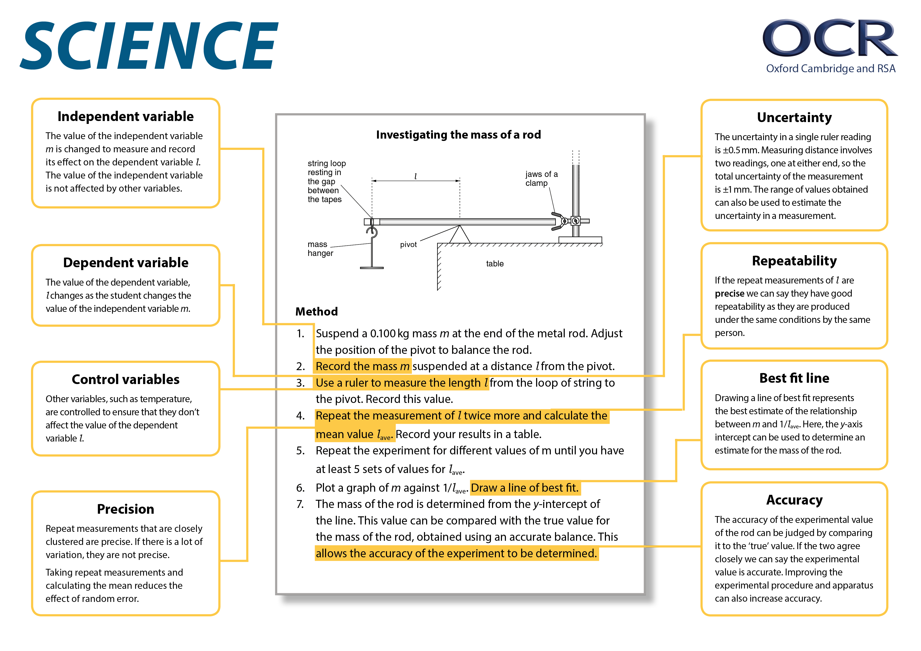

### Glossary of terms

| **Term** | **Definition** | **Notes** |
| --- | --- | --- |
| accuracy | a measurement result is considered accurate if it is judged to be close to the true/acceptable value | Accuracy is a property of a single result. Random and systematic errors can affect accuracy. |
| anomaly (outlier) | value in a set of results that is judged not to be part of the inherent variation | Calculate the mean without the anomaly if you suspect an anomaly due to an error or due to different conditions.  If you identify an anomaly during the practical, then consider repeating the measurement.  In **Maths**, you may use the term ‘outlier’. |
| control variable | variables other than the independent and dependent variables which are kept the same | These are quantities or conditions that are kept the same in a practical. Changes in these conditions could affect the validity of your method and results. |
| dependent variable | variable which is measured whenever there is a change in the independent variable | The dependent variable are recorded as either numerical values with units (quantitative) or in the form of descriptive comments (qualitative). |
| independent variable | variable which is deliberately changed by the person in the planning of a practical activity | The independent variable is recorded in the first column of a results table.  The dependent variable is recorded to the right with processed data in the far right columns.  In a graph, the independent variable is usually plotted on the *x*-axis with the dependent variable on the *y*-axis. |
| line of best fit | a line drawn on a graph that passes as close as possible to the data points. It represents the best estimate of the underlying relationship between the variables. | A line of best fit can be a straight line or a curve.  This differs from **GCSE** **Maths**, where a line of best fit is always a straight line. |
| precision | a quality denoting the closeness of agreement between measured values obtained by repeated measurements | Precision refers to more than one value. Precise results are clustered together. You can only determine if your results are precise by repeating the measurement.  Reducing the effect of random errors improves precision. A systematic error does not affect precision, as it is the same error each time. You may have precise results with a systematic error, but not accurate results. |
| random error | error in a measurement due to small uncontrollable effects | We can’t correct random errors, but we can reduce their effect by making more measurements and calculating the mean.  Random errors contribute to uncertainty. |
| range (of a variable) | the maximum and minimum values of the independent or dependent variables | In **Maths** the range is the difference between the biggest and smallest value of a variable. |
| repeatability | precision obtained when measurement results are produced in one laboratory, by a single operator, using the same conditions, over a short timescale | A measurement is repeatable when repetition under the same conditions gives similar results.  Anomalous results can be identified by repeating the measurement. However, never discard data simply because it does not correspond with expectations. |
| reproducibility | precision obtained when measurement results are produced by different laboratories and therefore by different operators using different pieces of equipment | A measurement is reproducible when similar results are produced by different groups or different equipment or altered methods. If the results are reproducible then you can be confident in the quality of the result. |
| resolution | smallest change in the input quantity being measured by a measuring instrument that gives a perceptible change in the reading of the measuring instrument | For example, the resolution of a ruler is 1mm and the resolution of a burette is 0.1cm3. It is not correct to describe equipment with a higher resolution as being more precise, as precision is a property of repeated results. |
| systematic error | error due to the measured value differing from the true value by the same amount each time | Methods or equipment may introduce systematic errors, producing consistent errors in results. Using the same equipment each time avoids introducing more systematic errors. Calibrating equipment where appropriate reduces systematic errors.  A **zero error** is when the measuring device indicates a value when the quantity being measured is zero.  Systematic errors contribute to uncertainty. |
| uncertainty | interval within which the true value can be expected to lie, with a given level of confidence or probability | Uncertainties depend on a range of factors, including systematic and random errors.  Analogue apparatus typically have an uncertainty of ± half the smallest graduation.  The uncertainty of the digital apparatus is ± the resolution of the apparatus. |
| validity (of an experiment) | suitability of the method used to answer the question being asked | To ensure validity, identify control variables and keep them constant to avoid affecting the dependent variables.  In the case of field studies there are naturally changing variables. Ensure the control variables are as similar as possible when repeating. |



We’d like to know your view on the resources we produce. Click ‘[Like’](mailto:resources.feedback@ocr.org.uk?subject=I%20liked%20the%20GCSE%20(9-1),%20A%20Level%20and%20AS%20Level%20Physics%20A%20and%20B%20Skills%20Guide%20-%20Language%20of%20measurement%20in%20context) or ‘[Dislike’](mailto:resources.feedback@ocr.org.uk?subject=I%20disliked%20the%20GCSE%20(9-1),%20A%20Level%20and%20AS%20Level%20Physics%20A%20and%20B%20Skills%20Guide%20-%20Language%20of%20measurement%20in%20context) to send us an auto generated email about this resource. Add comments if you want to. Let us know how we can improve this resource or what else you need. Your email will not be used or shared for any marketing purposes.

Looking for another resource? There is now a quick and easy search [tool to help find free resources](http://www.ocr.org.uk/i-want-to/find-resources/) for your qualification.

OCR is part of Cambridge Assessment, a department of the University of Cambridge.

For staff training purposes and as part of our quality assurance programme your call may be recorded or monitored.   
Oxford Cambridge and RSA Examinations is a Company Limited by Guarantee. Registered in England. Registered office   
The Triangle Building, Shaftesbury Road, Cambridge, CB2 8EA. Registered company number 3484466. OCR is an exempt charity.

OCR operates academic and vocational qualifications regulated by Ofqual, Qualifications Wales and CCEA as listed   
in their qualifications registers including A Levels, GCSEs, Cambridge Technicals and Cambridge Nationals.

OCR provides resources to help you deliver our qualifications. These resources do not represent any particular teaching method we expect you to use. We update our resources regularly and aim to make sure content is accurate but please check the OCR website so that you have the most up to date version. OCR cannot be held responsible for any errors or omissions in these resources.

Though we make every effort to check our resources, there may be contradictions between published support and the specification, so it is important that you always use information in the latest specification. We indicate any specification changes within the document itself, change the version number and provide a summary of the changes. If you do notice a discrepancy between the specification and a resource, please [contact us](mailto:resources.feedback@ocr.org.uk).

© OCR 2021 - You can copy and distribute this resource freely if you keep the OCR logo and this small print intact and you acknowledge OCR as the originator of the resource.

OCR acknowledges the use of the following content: N/A

Whether you already offer OCR qualifications, are new to OCR or are thinking about switching, you can request more information using our [Expression of Interest form](https://www.ocr.org.uk/qualifications/expression-of-interest/).

Please [get in touch](mailto:resources.feedback@ocr.org.uk) if you want to discuss the accessibility of resources we offer to support you in delivering our qualifications.