Foundation Check In - 6.05 Language of functions

- Use the function machine to find the value of y when x = 2.5.

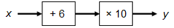

- Complete the empty box in the function machine below.

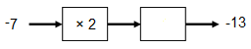

- Find a formula for y in terms of x for this function machine.

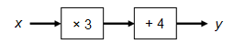

- Complete the empty boxes in the function machine below.

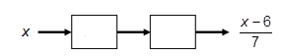

- Plumbright charge their customers for plumbing work in the following way.
- £20 callout fee: everyone pays this once, no matter how long the job takes.
- £30 for every hour worked.

Complete the empty boxes below to give a function for the cost (£c) in terms of the time it takes to complete the job (t hours).

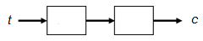

- Zia inputs some numbers to this function machine and notices that she always gets an output that is an odd number.

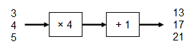

Zia claims this function machine will always output an odd number. Zia is wrong. Explain why. [1.02a initial]

- Gemma has a burst pipe and needs to call out a plumber. She considers Plumbright from question 5 but also asks another plumbing company, Dripdrip, for details of how much they charge.

Dripdrip have a higher callout fee of £40, but then charge a lower hourly rate of £20 for every hour worked. Gemma wants to pay as little as possible.

By considering the length of job for which the two companies would charge the same price, explain which company Gemma should choose.

- These two function machines will give the same output for a particular input.

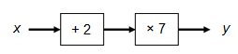

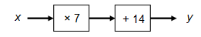

For each function machine, find a formula for y in terms of x. Show that these two formulas are equivalent.

- Benji asks his teacher how old he is. His teacher replies “if you add 3 to my age, divide that value by 2 and then subtract 5, you get 16”. How old is Benji’s teacher?

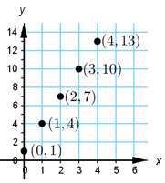
- The graph on the right shows five pairs of numbers (x, y).

Complete the boxes below to give a function machine
that could have been used to generate the five pairs
of numbers.

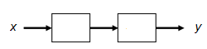

Extension

Complete the empty boxes in the function machine below.

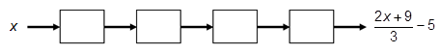

Check that your function machine gives an output of 2 when you input 6.

Use your function machine to work out the input values which give an output of
(a) 6,
(b) -2.

Only some inputs give outputs that are integers. What is special about these input values?
Answers

- 85

- + 1

- y = 3x + 4

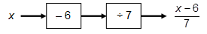

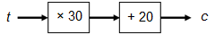

- This function machine will always give an odd number for an integer input (or an input that ends in .5). One counterexample is sufficient to show Zia is wrong.If she inputs, for example 0.25, she gets an output of 2, which is even. Also, if she inputs, for example 1.1, she gets 5.1 which is neither even nor odd.

- At two hours, the companies both charge £80. If the job will take up to two hours, Gemma should use Plumbright; if the job will take over two hours, Gemma should use Dripdrip.

- The first function machine represents . The second function machine represents . Expanding the brackets of the first formula gives the same formula as the one for the second function machine.

- 36 years old

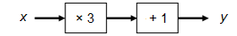

Extension

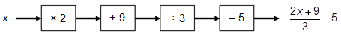

(a) Input 12
(b) Input 0

Inputs that are a multiple of 3 are the only values that give outputs that are integer values.

We’d like to know your view on the resources we produce. By clicking on ‘Like’ or ‘Dislike’ you can help us to ensure that our resources work for you. When the email template pops up please add additional comments if you wish and then just click ‘Send’. Thank you.
Whether you already offer OCR qualifications, are new to OCR, or are considering switching from your current provider/awarding organisation, you can request more information by completing the Expression of Interest form which can be found here: www.ocr.org.uk/expression-of-interest
Looking for a resource? There is now a quick and easy search tool to help find free resources for your qualification:
www.ocr.org.uk/i-want-to/find-resources/

OCR Resources: the small print
OCR’s resources are provided to support the delivery of OCR qualifications, but in no way constitute an endorsed teaching method that is required by the Board, and the decision to use them lies with the individual teacher. Whilst every effort is made to ensure the accuracy of the content, OCR cannot be held responsible for any errors or omissions within these resources. This formative assessment resource has been produced as part of our free GCSE teaching and learning support package. All the GCSE teaching and learning resources, including delivery guides, topic exploration packs, lesson elements and more are available on the qualification webpages. If you are looking for examination practice materials, you can find Sample Assessment Materials (SAMs) and Practice Papers on the qualification webpage http://www.ocr.org.uk/qualifications/gcse-mathematics-j560-from-2015/
© OCR 2019 - This resource may be freely copied and distributed, as long as the OCR logo and this message remain intact and OCR is acknowledged as the originator of this work.
OCR acknowledges the use of the following content: n/a
Please get in touch if you want to discuss the accessibility of resources we offer to support delivery of our qualifications: resources.feedback@ocr.org.uk
To give us feedback on, or ideas about the OCR resources you have used, email resourcesfeedback@ocr.org.uk
To give us feedback on, or ideas about the OCR resources you have used, email resourcesfeedback@ocr.org.uk
To give us feedback on, or ideas about the OCR resources you have used, email resourcesfeedback@ocr.org.uk
To give us feedback on, or ideas about the OCR resources you have used, email resourcesfeedback@ocr.org.uk
To give us feedback on, or ideas about the OCR resources you have used, email resourcesfeedback@ocr.org.uk
To give us feedback on, or ideas about the OCR resources you have used, email resourcesfeedback@ocr.org.uk
OCR Resources: the small print
OCR’s resources are provided to support the teaching of OCR specifications, but in no way constitute an endorsed teaching method that is required by the Board, and the decision to use them lies with the individual teacher. Whilst every effort is made to ensure the accuracy of the content, OCR cannot be held responsible for any errors or omissions within these resources.
© OCR 2014 - This resource may be freely copied and distributed, as long as the OCR logo and this message remain intact and OCR is acknowledged as the originator of this work.

OCR Resources: the small print
OCR’s resources are provided to support the teaching of OCR specifications, but in no way constitute an endorsed teaching method that is required by the Board, and the decision to use them lies with the individual teacher. Whilst every effort is made to ensure the accuracy of the content, OCR cannot be held responsible for any errors or omissions within these resources.
© OCR 2014 - This resource may be freely copied and distributed, as long as the OCR logo and this message remain intact and OCR is acknowledged as the originator of this work.
OCR acknowledges the use of the following content::
Garden: Elen Eliseeva/Shutterstock.com Flag: Pixel Europe/Shutterstock.com

To give us feedback on, or ideas about the OCR resources you have used, email resourcesfeedback@ocr.org.uk
Assessment Objective | Qu. | Topic | R | A | G |  | Assessment Objective | Qu. | Topic | R | A | G
AO1 | 1 | Substitute decimal value into function machine |  |  |  |  | AO1 | 1 | Substitute decimal value into function machine
AO1 | 2 | Determine missing operation in function machine |  |  |  |  | AO1 | 2 | Determine missing operation in function machine
AO1 | 3 | Write formula for function machine |  |  |  |  | AO1 | 3 | Write formula for function machine
AO1 | 4 | Determine function machine for formula |  |  |  |  | AO1 | 4 | Determine function machine for formula
AO1 | 5 | Determine function machine for pricing model in context |  |  |  |  | AO1 | 5 | Determine function machine for pricing model in context
AO2 | 6 | Explain properties of multiples and odd numbers |  |  |  |  | AO2 | 6 | Explain properties of multiples and odd numbers
AO2 | 7 | Use function machine for pricing model in context |  |  |  |  | AO2 | 7 | Use function machine for pricing model in context
AO2 | 8 | Use function machines and expanding brackets to show two expressions are equivalent |  |  |  |  | AO2 | 8 | Use function machines and expanding brackets to show two expressions are equivalent
AO3 | 9 | Use function machine to solve a problem |  |  |  |  | AO3 | 9 | Use function machine to solve a problem
AO3 | 10 | Determine function machine for coordinate pairs |  |  |  |  | AO3 | 10 | Determine function machine for coordinate pairs
Assessment Objective | Qu. | Topic | R | A | G |  | Assessment Objective | Qu. | Topic | R | A | G
AO1 | 1 | Substitute decimal value into function machine |  |  |  |  | AO1 | 1 | Substitute decimal value into function machine
AO1 | 2 | Determine missing operation in function machine |  |  |  |  | AO1 | 2 | Determine missing operation in function machine
AO1 | 3 | Write formula for function machine |  |  |  |  | AO1 | 3 | Write formula for function machine
AO1 | 4 | Determine function machine for formula |  |  |  |  | AO1 | 4 | Determine function machine for formula
AO1 | 5 | Determine function machine for pricing model in context |  |  |  |  | AO1 | 5 | Determine function machine for pricing model in context
AO2 | 6 | Explain properties of multiples and odd numbers |  |  |  |  | AO2 | 6 | Explain properties of multiples and odd numbers
AO2 | 7 | Use function machine for pricing model in context |  |  |  |  | AO2 | 7 | Use function machine for pricing model in context
AO2 | 8 | Use function machines and expanding brackets to show two expressions are equivalent |  |  |  |  | AO2 | 8 | Use function machines and expanding brackets to show two expressions are equivalent
AO3 | 9 | Use function machine to solve a problem |  |  |  |  | AO3 | 9 | Use function machine to solve a problem
AO3 | 10 | Determine function machine for coordinate pairs |  |  |  |  | AO3 | 10 | Determine function machine for coordinate pairs

