# Foundation Check In – 3.03 Exact calculations

**Do not use a calculator.**

1. Work out the mean of    and 
2. A giant tortoise travelled  of a mile in 40 minutes. What was the average speed of the giant tortoise in miles per hour?
3. What number is half way between  and ?
4. A circle of radius 10 cm is split into ten pieces of equal area. What is the exact area of each piece?
5. Simplify .
6. Show that .
7. Show that the difference in the area of these two sectors is cm2.

4 cm

60°

2 cm

60°

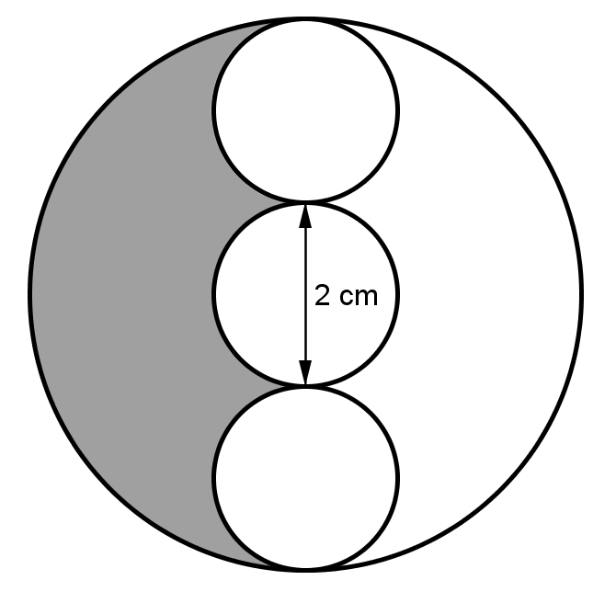

1. The big circle on the right has three circular holes cut out of it. The three holes are congruent and have diameter

2 cm. When the holes are cut, the big circle is split into two parts. Show that the area of the shaded part is cm2.

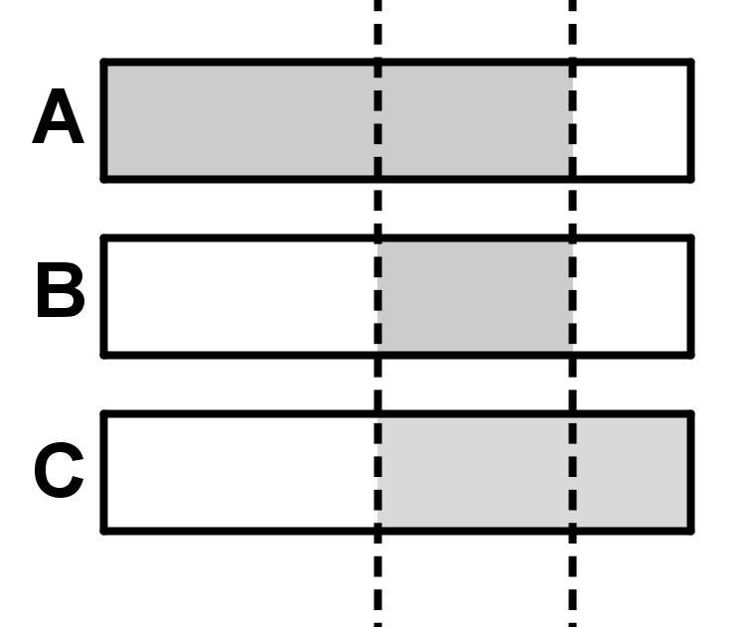

1. The three rectangles on the right are identical in size.

Rectangle A has  shaded.

Rectangle C has  shaded.

Work out the fraction of rectangle B that is shaded.

1. The diagram below shows an archery target that is made up of 4 concentric circles. Calculate the fraction of the total area of the target that is shaded. Give your answer in its simplest form.

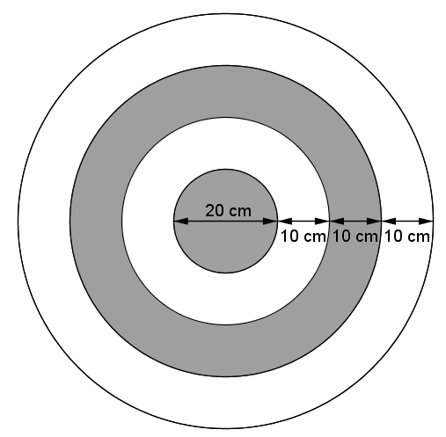

**Extension**

Unit fractions are fractions whose numerator is equal to 1. For example,  or  are unit fractions.

You can make other fractions by adding together unit fractions. For example, which shows that  can be made by adding two unit fractions.

Can you find ways of making  by adding three **different** unit fractions?

## Answers

1. 
2.  miles per hour.
3. 
4. Area of whole circle is , so each piece is cm2.
5.  or 
6. 
7. cm2
8. The big circle has diameter 6 cm, so radius 3 cm. Its area is cm2. Each small circle has radius 1 cm2, so area cm2. After three holes have been cut out of the big circle, the remaining area is cm2. The shaded area is half of this i.e.cm2.
9. The unshaded area of B is equal to the unshaded areas of A and C added together so the shaded area is .

Or shaded area of B  shaded area of C – unshaded area of A, so .

Or shaded area of B  shaded area of A – unshaded area of C, so .

1. Total area is cm2. The inner shaded circle has area cm2. The shaded ring has area cm2. So the fraction of the target that is shaded is .

**Extension**

There are three ways of making  by adding together different unit fractions:

,  and .

We’d like to know your view on the resources we produce. By clicking on ‘[Like](mailto:resources.feedback@ocr.org.uk?subject=I%20liked%20the%20GCSE%20(9-1)%20Mathematics%20Foundation%20Check%20In%20–%203.03%20Exact%20calculations)’ or ‘[Dislike](mailto:resources.feedback@ocr.org.uk?subject=I%20disliked%20the%20GCSE%20(9-1)%20Mathematics%20Foundation%20Check%20In%20–%203.03%20Exact%20calculations)’ you can help us to ensure that our resources work for you. When the email template pops up please add additional comments if you wish and then just click ‘Send’. Thank you.

If you do not currently offer this OCR qualification but would like to do so, please complete the Expression of Interest Form which can be found here: [www.ocr.org.uk/expression-of-interest](http://www.ocr.org.uk/expression-of-interest)

**OCR Resources**: *the small print*OCR’s **resources** are provided to support the teaching of OCR specifications, but in no way constitute an endorsed teaching method that is required by the Board, and the decision to use them lies with the individual teacher. Whilst every effort is made to ensure the accuracy of the content, OCR cannot be held responsible for any errors or omissions within these resources.   
© OCR 2016 - This resource may be freely copied and distributed, as long as the OCR logo and this message remain intact and OCR is acknowledged as the originator of this work.

OCR acknowledges the use of the following content: n/a

Please get in touch if you want to discuss the accessibility of resources we offer to support delivery of our qualifications: [resources.feedback@ocr.org.uk](mailto:resources.feedback@ocr.org.uk)

To give us feedback on, or ideas about the OCR resources you have used, email [resourcesfeedback@ocr.org.uk](mailto:resourcesfeedback@ocr.org.uk)

To give us feedback on, or ideas about the OCR resources you have used, email [resourcesfeedback@ocr.org.uk](mailto:resourcesfeedback@ocr.org.uk)

To give us feedback on, or ideas about the OCR resources you have used, email [resourcesfeedback@ocr.org.uk](mailto:resourcesfeedback@ocr.org.uk)

To give us feedback on, or ideas about the OCR resources you have used, email [resourcesfeedback@ocr.org.uk](mailto:resourcesfeedback@ocr.org.uk)

To give us feedback on, or ideas about the OCR resources you have used, email [resourcesfeedback@ocr.org.uk](mailto:resourcesfeedback@ocr.org.uk)

To give us feedback on, or ideas about the OCR resources you have used, email [resourcesfeedback@ocr.org.uk](mailto:resourcesfeedback@ocr.org.uk)

**OCR Resources**: *the small print*OCR’s resources are provided to support the teaching of OCR specifications, but in no way constitute an endorsed teaching method that is required by the Board, and the decision to use them lies with the individual teacher. Whilst every effort is made to ensure the accuracy of the content, OCR cannot be held responsible for any errors or omissions within these resources.   
© OCR 2014 - This resource may be freely copied and distributed, as long as the OCR logo and this message remain intact and OCR is acknowledged as the originator of this work.

**OCR Resources**: *the small print*OCR’s resources are provided to support the teaching of OCR specifications, but in no way constitute an endorsed teaching method that is required by the Board, and the decision to use them lies with the individual teacher. Whilst every effort is made to ensure the accuracy of the content, OCR cannot be held responsible for any errors or omissions within these resources.   
© OCR 2014 - This resource may be freely copied and distributed, as long as the OCR logo and this message remain intact and OCR is acknowledged as the originator of this work.

OCR acknowledges the use of the following content::  
⚫ Garden: Elen Eliseeva/Shutterstock.com ⚫ Flag: Pixel Europe/Shutterstock.com

To give us feedback on, or ideas about the OCR resources you have used, email resourcesfeedback@ocr.org.uk

|  | **Qu.** | **Topic** | **R** | **A** | **G** |  | **Assessment Objective** | **Qu.** | **Topic** | **R** | **A** | **G** |
| --- | --- | --- | --- | --- | --- | --- | --- | --- | --- | --- | --- | --- |
| AO1 | 1 | Add fractions then divide a fraction by an integer |  |  |  |  | AO1 | 1 | Add fractions then divide a fraction by an integer |  |  |  |
| AO1 | 2 | Carry out a speed calculation involving fractions |  |  |  |  | AO1 | 2 | Carry out a speed calculation involving fractions |  |  |  |
| AO1 | 3 | Find a fraction half way between two fractions |  |  |  |  | AO1 | 3 | Find a fraction half way between two fractions |  |  |  |
| AO1 | 4 | Use multiples of  in an exact calculation of the area of a proportion of a circle |  |  |  |  | AO1 | 4 | Use multiples of  in an exact calculation of the area of a proportion of a circle |  |  |  |
| AO1 | 5 | Simplify an expression involving fractions and |  |  |  |  | AO1 | 5 | Simplify an expression involving fractions and |  |  |  |
| AO2 | 6 | Multiply mixed numbers and simplify |  |  |  |  | AO2 | 6 | Multiply mixed numbers and simplify |  |  |  |
| AO2 | 7 | Use multiples of  in an exact calculation involving the areas of two sectors |  |  |  |  | AO2 | 7 | Use multiples of  in an exact calculation involving the areas of two sectors |  |  |  |
| AO2 | 8 | Use multiples of  in an exact calculation of the area of a proportion of a compound shape involving circles |  |  |  |  | AO2 | 8 | Use multiples of  in an exact calculation of the area of a proportion of a compound shape involving circles |  |  |  |
| AO3 | 9 | Solve a problem involving fractions of rectangles |  |  |  |  | AO3 | 9 | Solve a problem involving fractions of rectangles |  |  |  |
| AO3 | 10 | Solve a problem involving exact areas of circles |  |  |  |  | AO3 | 10 | Solve a problem involving exact areas of circles |  |  |  |
|  |  |  |  |  |  |  |  |  |  |  |  |  |
| **Assessment Objective** | **Qu.** | **Topic** | **R** | **A** | **G** |  | **Assessment Objective** | **Qu.** | **Topic** | **R** | **A** | **G** |
| AO1 | 1 | Add fractions then divide a fraction by an integer |  |  |  |  | AO1 | 1 | Add fractions then divide a fraction by an integer |  |  |  |
| AO1 | 2 | Carry out a speed calculation involving fractions |  |  |  |  | AO1 | 2 | Carry out a speed calculation involving fractions |  |  |  |
| AO1 | 3 | Find a fraction half way between two fractions |  |  |  |  | AO1 | 3 | Find a fraction half way between two fractions |  |  |  |
| AO1 | 4 | Use multiples of  in an exact calculation of the area of a proportion of a circle |  |  |  |  | AO1 | 4 | Use multiples of  in an exact calculation of the area of a proportion of a circle |  |  |  |
| AO1 | 5 | Simplify an expression involving fractions and |  |  |  |  | AO1 | 5 | Simplify an expression involving fractions and |  |  |  |
| AO2 | 6 | Multiply mixed numbers and simplify |  |  |  |  | AO2 | 6 | Multiply mixed numbers and simplify |  |  |  |
| AO2 | 7 | Use multiples of  in an exact calculation involving the areas of two sectors |  |  |  |  | AO2 | 7 | Use multiples of  in an exact calculation involving the areas of two sectors |  |  |  |
| AO2 | 8 | Use multiples of  in an exact calculation of the area of a proportion of a compound shape involving circles |  |  |  |  | AO2 | 8 | Use multiples of  in an exact calculation of the area of a proportion of a compound shape involving circles |  |  |  |
| AO3 | 9 | Solve a problem involving fractions of rectangles |  |  |  |  | AO3 | 9 | Solve a problem involving fractions of rectangles |  |  |  |
| AO3 | 10 | Solve a problem involving exact areas of circles |  |  |  |  | AO3 | 10 | Solve a problem involving exact areas of circles |  |  |  |