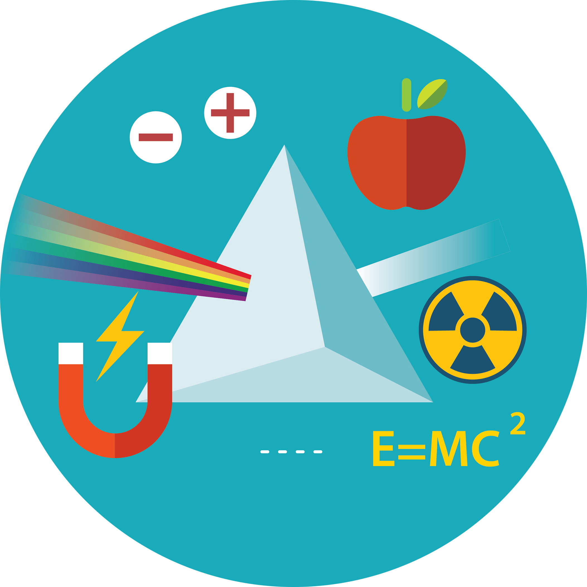

Physics / Combined Science

GCSE (9–1) Gateway and Twenty First Century

Practical Activity

Learner Record Sheet

You will be given the opportunity to carry out a minimum of eight practical activities for each separate science or 16 practical activities for combined sciences.
Name
Class
Teacher
School

List of apparatus and techniques
The following list includes opportunities for choice and use of appropriate laboratory apparatus for a variety of experimental problem-solving and/or enquiry based activities.
Safety is an overriding requirement for all practical work. Centres are responsible for ensuring appropriate safety procedures are followed whenever their students complete practical work.
Use and production of appropriate scientific diagrams to set up and record apparatus and procedures used in practical work is common to all science subjects and should be included wherever appropriate.
Combined science and Separate science (Physics)
1a Use of appropriate apparatus to make and record a range of measurements accurately, including: |  |  |  | 
i |  | length
ii |  | area
iii |  | mass
iv |  | time
v |  | volume
vi |  | temperature
 |  | The learner/I have completed this section
1b Use of such measurements to determine: |  |  |  | 
i |  | densities of solid objects
ii |  | densities of liquid objects
 |  | The learner/I have completed this section
2 Use of appropriate apparatus to measure and observe the effects of forces including the extension of springs. |  |  |  | 
 |  | The learner/I have completed this section
3 Use of appropriate apparatus and techniques for measuring motion, including determination of: |  |  |  | 
i |  | speed
ii |  | rate of change of speed (acceleration/deceleration)
 |  | The learner/I have completed this section
4a Making observations of waves in fluids and solids to identify the suitability of apparatus to measure: |  |  |  | 
i |  | speed
ii |  | frequency
ii |  | wavelength
 |  | The learner/I have completed this section

4b Making observations of the effects of the interaction of electromagnetic waves with matter. |  |  |  | 
 |  | The learner/I have completed this section
5 Safe use of appropriate apparatus in a range of contexts to measure: |  |  |  | 
i |  | energy changes/transfers
ii |  | associated values such as work done
 |  | The learner/I have completed this section
6a Use of appropriate apparatus to measure: |  |  |  | 
i |  | current
ii |  | potential difference
iii |  | resistance
 |  | The learner/I have completed this section
6b Use of appropriate apparatus to explore a variety of circuit elements. |  |  |  | 
 |  | The learner/I have completed this section
7 Use of circuit diagrams to construct and check: |  |  |  | 
i |  | series circuits including a variety of common circuit elements
ii |  | parallel circuits including a variety of common circuit elements
 |  | The learner/I have completed this section
Separate science (Physics) ONLY
8 Making observations of waves to identify the suitability of apparatus to measure the effects of interactions of waves with matter in: |  |  |  | 
i |  | fluids
ii |  | solids
 |  | The learner/I have completed this section
Please turn over
Practical activity record sheet
Record the practical activities you have carried out below. If additional pages are required a copy of this page can be attached.
No. |  | Date | Practical done
1
2
3
4
5
6
7
8
9
10
11
12
13
14
15
16
17
18
19
20
21
22
23
24
We’d like to know your view on the resources we produce. By clicking on ‘Like’ or ‘Dislike’ you can help us to ensure that our resources work for you. When the email template pops up please add additional comments if you wish and then just click ‘Send’. Thank you.
If you do not currently offer this OCR qualification but would like to do so, please complete the Expression of Interest Form which can be found here: www.ocr.org.uk/expression-of-interest

OCR Resources: the small print
OCR’s resources are provided to support the teaching of OCR specifications, but in no way constitute an endorsed teaching method that is required by the Board, and the decision to use them lies with the individual teacher. Whilst every effort is made to ensure the accuracy of the content, OCR cannot be held responsible for any errors or omissions within these resources.
© OCR 2016 - This resource may be freely copied and distributed, as long as the OCR logo and this message remain intact and OCR is acknowledged as the originator of this work.
OCR acknowledges the use of the following content: shutterstock/kaisorn
Please get in touch if you want to discuss the accessibility of resources we offer to support delivery of our qualifications: resources.feedback@ocr.org.uk

