Multiple Choice Questions (MCQ) topic quiz

Chemical Industry

Instructions and answers for teachers
These instructions cover the student activity section which can be found on page 10. This Lesson Element supports OCR A Level Chemistry B (Salters).
When distributing the activity section to the students either as a printed copy or as a Word file you will need to remove the teacher instructions section.

The Activity
This Lesson Element is a teaching and learning resource containing 10 multiple choice questions (MCQs) on the theme of the chemical industry. Some questions might require synoptic thinking, using knowledge and ideas from various topics across the full A Level content.
This resource can be used to test and consolidate understanding at the end of a topic or to revisit and refresh knowledge at a later point in the course.
Learning Outcomes
This Lesson Element relates to the specification learning outcomes CI(a), CI(b), CI(c), CI(d), CI(e), CI(f), CI(g), CI(j).
Introduction
Multiple choice questions allow rapid coverage of a wide range of sub-topics.
Contrary to a widespread belief among students, multiple choice questions are not necessarily easy – they can be easy, moderate or difficult.
The questions are written so that the incorrect answers are plausible distractors based on common errors or misconceptions.
The questions in this quiz cover topics mainly from specification sections:
The chemical industry.

Multiple Choice Questions (MCQ) topic quiz - answers
- A reaction is first order with respect to a particular reactant.
Which graph shows the relationship of rate against concentration for this reactant?

A | Correct answer: If a reaction is first order with respect to a reactant, then the rate is directly proportional to the concentration of that reactant.
B | The learner is confusing the concentration/time graph for the product of a first order reaction.
C | This is the rate/concentration graph for a second order reactant.
D  A | The learner is confusing the concentration/time graph for a first order reactant.
Your answer
- Consider the following reaction:
P + Q R + S
The reaction is
- first order with respect to P
- zero order with respect to Q
- first order with respect to the acid catalyst.
What are the units of the rate constant for the reaction?
A | mol^{–1} dm³ | The learner has neglected to include the s^{–1} component of the units for rate.
B | mol^{–1} dm³ s^{–1} | Correct answer: The rate constant is equal to the rate in mol dm^{–3} s^{–1} divided by the product of the concentrations of P and H⁺.
C | mol dm^{–3} s^{–1} | The learner has made a careless error and has neglected to realise that mol/mol² = mol^{–1}.
D  B | mol^{–2} dm⁶ s^{–1} | The learner has either assumed a third order reaction (perhaps by including Q in the rate equation) or incorrectly simplified the units.
Your answer

- Which is the correct order of nitrogen-containing compounds, from the highest oxidation state of nitrogen to the lowest?
A | KNO₂, NO₂, NO | The nitrogen in NO₂ has a higher oxidation state than the nitrogen in KNO₂.
B | KNO₃, KNO₂, NO₂ | The first two are in order of decreasing oxidation state, but nitrogen in NO₂ has a higher oxidation state than that in KNO₂.
C | N₂O, NO, NH₄Cl | The nitrogen in NO has a higher oxidation state than the nitrogen in N₂O.
D  D | KNO₃, KNO₂, NH₄Cl | Correct answer: The oxidation states are in the order +5, +3, –3.
Your answer
- The rate equation for the reaction between iodine and propanone in the presence of an acid catalyst is as follows:
rate = k [propanone] [H⁺]
Which statement can be correctly deduced from the rate equation?
A | The iodine is not involved in the first step of the mechanism. | This cannot be deduced from the rate equation alone, since it is not necessarily true that the first step in the mechanism is the rate-determining step.
B | The rate is directly proportional to the concentration of hydrogen ions. | Correct answer: The reaction is first order with respect to H⁺.
C | The rate is equal to the product of the propanone and hydrogen ion concentrations. | The learner has ignored the presence of the rate constant.
D  B | The reaction can occur in the absence of iodine. | The learner has incorrectly assumed that the absence of a reactant in the rate equation means that it is not involved in the reaction at all, rather than not being involved in the rate-determining step.
Your answer

- When using the Arrhenius plot below, how is the activation energy for the reaction, in kJ mol^{–1}, correctly calculated?
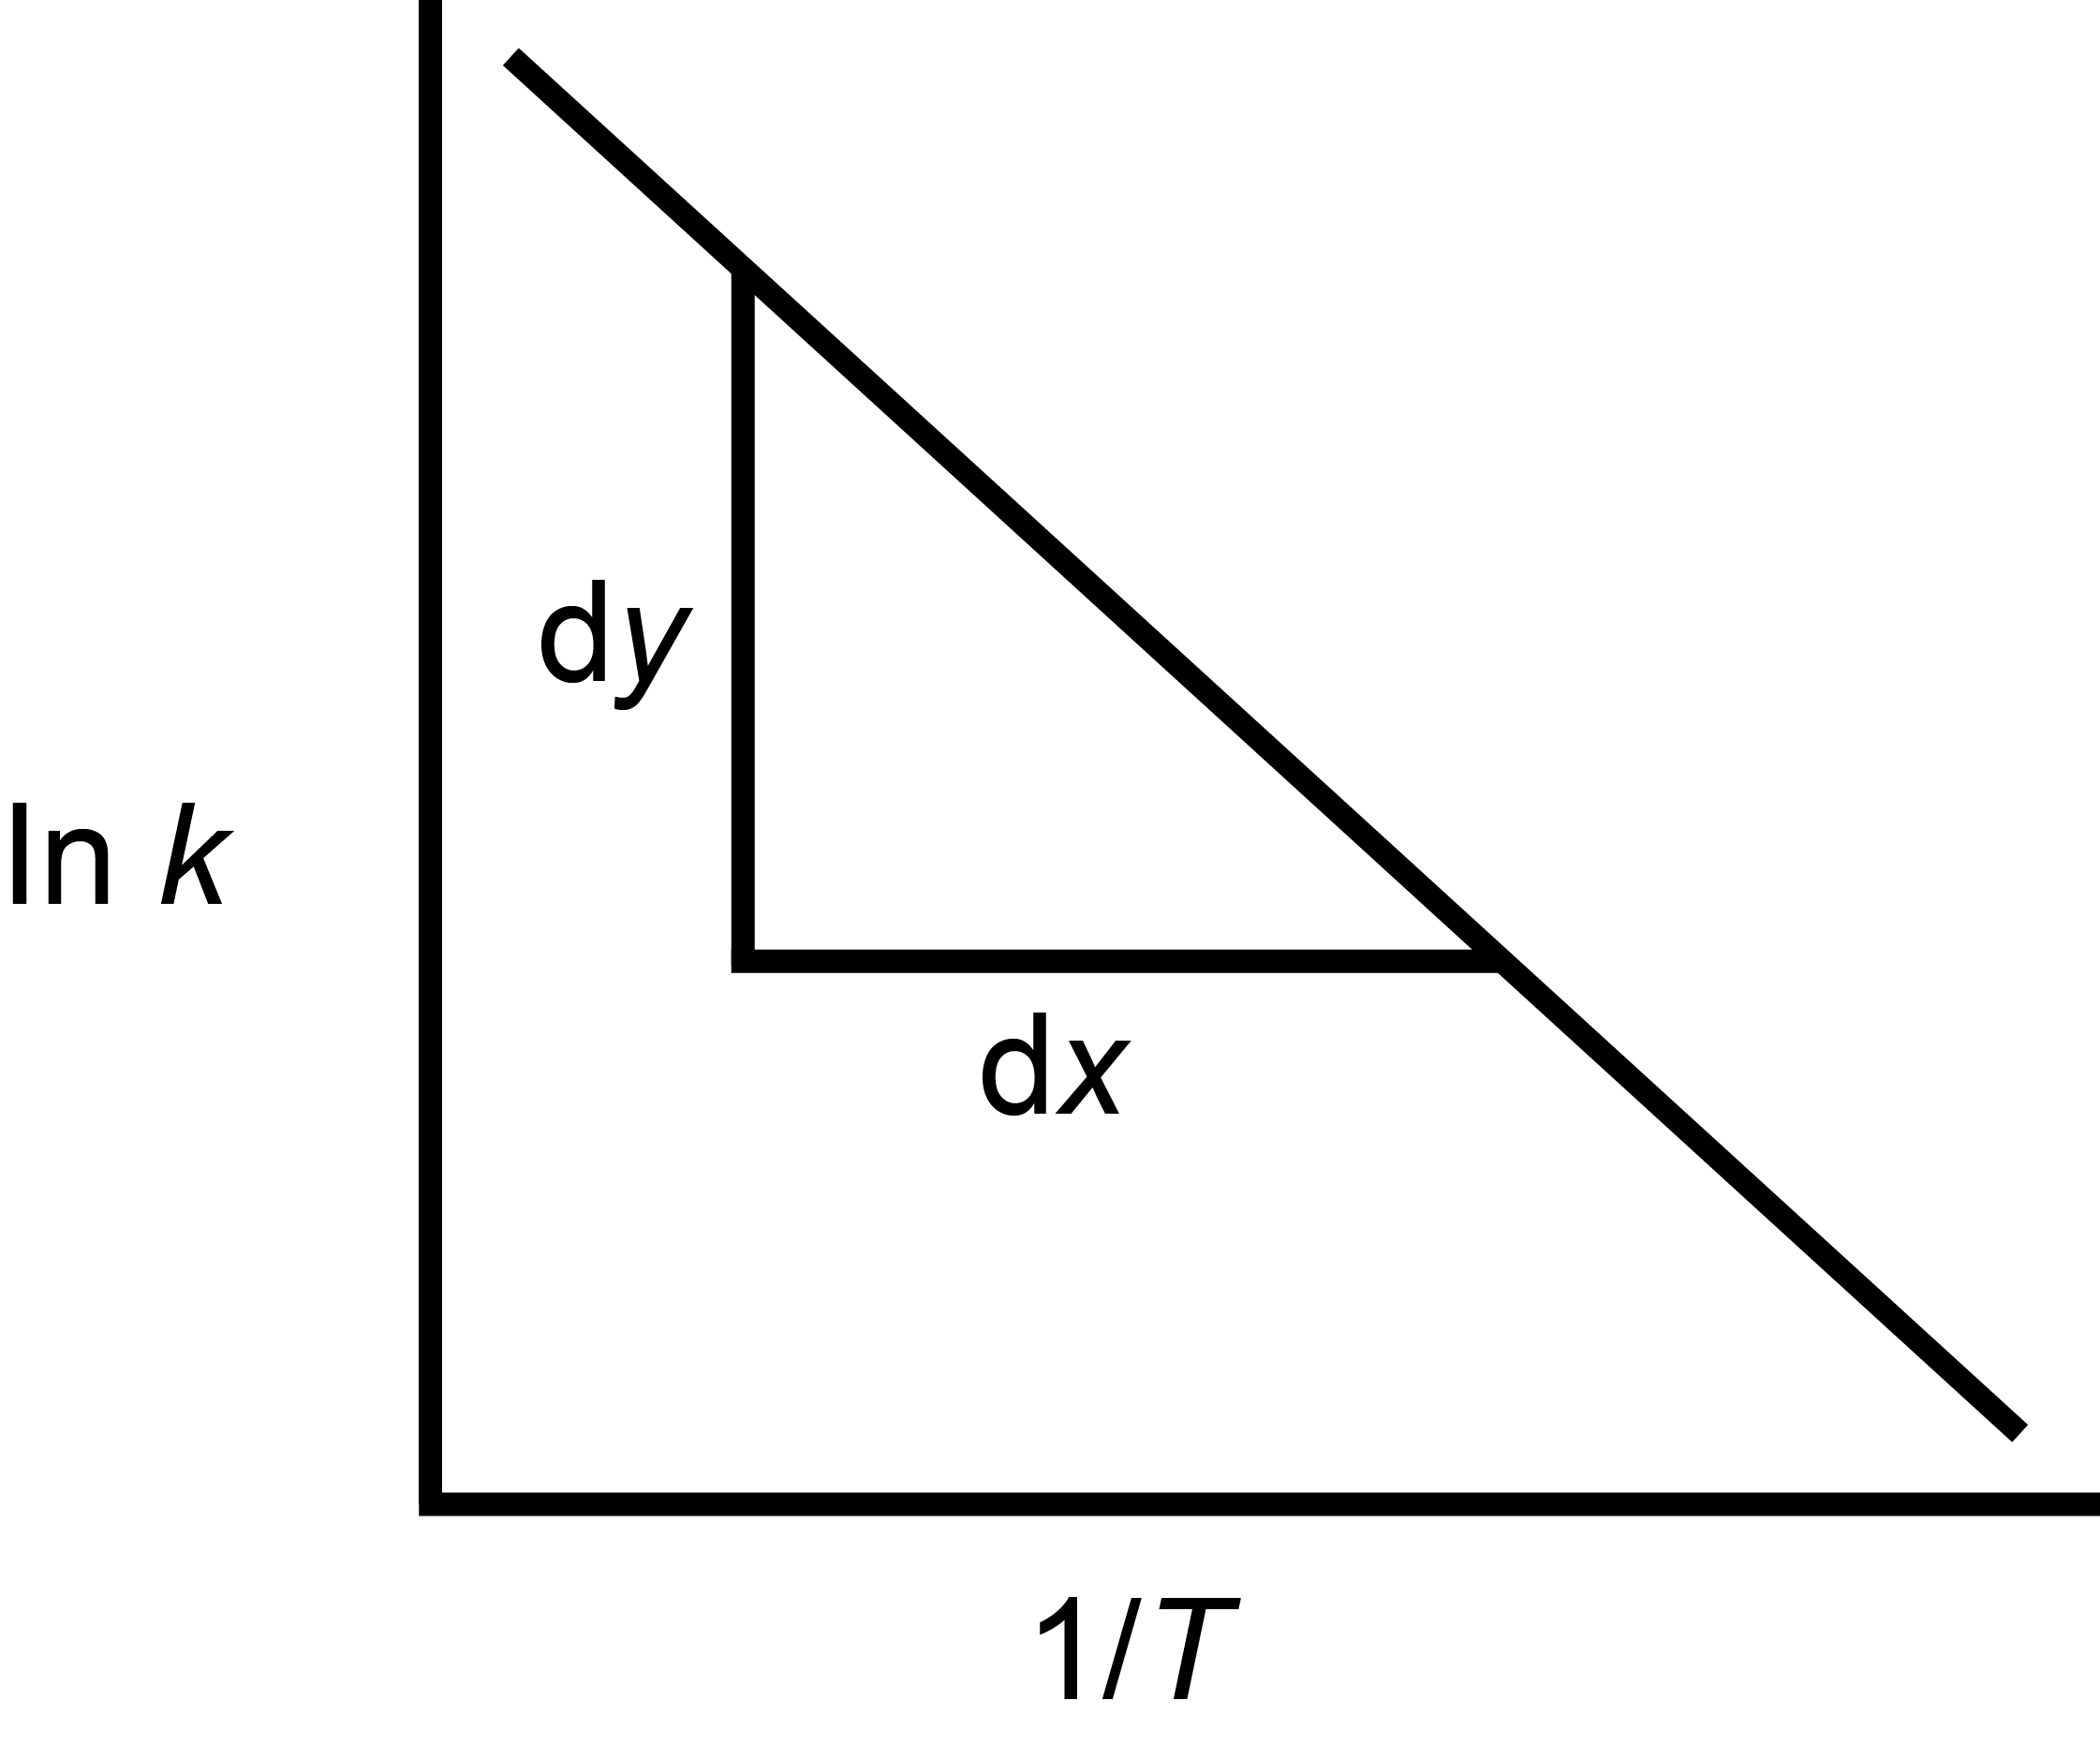

A | $$−\frac{dy}{dx}$$ | The learner has oversimplified the Arrhenius equation somewhat!
B | $$\left(−\frac{dy}{dx}\right)R$$ | The learner has neglected to convert J mol^{–1} to kJ mol^{–1}.
C | $${\left(−\frac{dy}{dx}\right)}/{\text{1000}}$$ | The learner has neglected to multiply by the gas constant.
D  D | $$\frac{\left(−\frac{dy}{dx}\right)}{\text{1000}}R$$ | Correct answer: The gradient is equal to  –E_{a}/R, but manipulation of this equation would give the answer in J mol^{–1} and so must also be divided by 1000.
Your answer
- Consider the following reaction:
N₂(g) + 3H₂(g) 2NH₃(g) ΔH = –ve
Which set of conditions would produce the best yield of ammonia?
A | high temperature, low pressure | This is the exact opposite of the optimum conditions for yield, however the learner may be thinking about the relatively high temperatures and low pressures used (for reasons of rate and cost) in the industrial Haber Process.
B | high temperature, high pressure | These would be the best conditions for rate, but high temperature would lower the yield since the forward reaction is exothermic.
C | low temperature, high pressure | Correct answer: Low temperature favours the forward reaction since it is exothermic; the reaction has fewer molecules of gas on the right hand side so would be favoured by high pressure.
D  C | low temperature, low pressure | Low temperature would increase yield but low pressure would not as there are fewer molecules of gas on the right hand side.
Your answer
- A reaction is first order with respect to the reactant Y. The reaction has a half-life of 5 minutes. The initial concentration of Y is 1.20 mol dm^{–3}.
What will be the concentration of Y after 15 minutes?
A | 0.15 mol dm^{–3} | Correct answer: Fifteen minutes is equal to three half-lives and so the concentration has halved three times.
B | 0.30 mol dm^{–3} | The learner has only counted two half-lives.
C | 0.40 mol dm^{–3} | The learner has divided the concentration by three instead of dividing it by two three times.
D  A | 1.50 mol dm^{–3} | The learner has misplaced a decimal point
Your answer

- A sample of ammonium chloride is warmed with aqueous sodium hydroxide and a pungent gas is evolved.
Which statement is true about this reaction?
A | Chlorine is also produced. | The learner is perhaps thinking of a redox process, or the disproportionation of chlorine.
B | Sodium chloride and water are also produced. | Correct answer: The reaction involves transfer of H⁺ from the ammonium ion to the hydroxide ion, and sodium chloride is left in solution.
C | The gas bleaches damp litmus paper. | The learner is confusing the action of ammonia on litmus with the action of chlorine.
D  B | The nitrogen is reduced. | The learner is confusing this reaction with the test for nitrate(V), which produces the same result through reduction.
Your answer
- The relative rates of a reaction between X and Z at different initial concentrations are shown in the table below:
Experiment | [X] / mol dm^{–3} | [Z] / mol dm^{–3} | Relative rate
1 | 0.1 | 0.1 | 1
2 | 0.3 | 0.1 | 9
3 | 0.2 | 0.2 | 4

What is the rate equation for this reaction?
A | rate = k[X][Z] | The learner has very much oversimplified the rate equation here and has not stopped to go through the maths properly.
B | rate = k[X][Z]² | The learner has seen a doubling in concentration of Z as resulting in a quadrupling of rate without taking into account the concurrent change in concentration of X.
C | rate = k[X]²[Z] | The learner has correctly deduced that the reaction is second order with respect to X from reactions 1 and 2, but has then missed the doubling in concentration of X between experiments 2 and 3.
D  D | rate = k[X]² | Correct answer: From experiments 1 and 2 it can be deduced that the reaction is second order with respect to X; therefore the difference in rate between 2 and 3 is independent of the change in concentration of Z.
Your answer
- Which statement(s) is/are true for the effect of a catalyst on a reversible reaction?
Statement 1: The value of K_{c} increases for both the forward and reverse reactions.
Statement 2: The value of E_{a} decreases for both the forward and reverse reactions.
Statement 3: The value of the rate constant increases for both the forward and reverse reactions.
A | 1, 2 and 3 | Statement 1 is untrue since the position of equilibrium is unaffected by the use of a catalyst.
B | only 1 and 2 | Statement 1 is untrue – see above. Statement 2 is true, hence the catalyst increasing the rate of both the forward and reverse reactions.
C | only 2 and 3 | Correct answer: By decreasing activation energy for both forward and reverse reactions, the rate constant must increase for both.
D  C | only 1 | Statement 1 is untrue – see above.
Your answer
OCR Resources: the small print
OCR’s resources are provided to support the teaching of OCR specifications, but in no way constitute an endorsed teaching method that is required by the Board, and the decision to use them lies with the individual teacher. Whilst every effort is made to ensure the accuracy of the content, OCR cannot be held responsible for any errors or omissions within these resources.
© OCR 2016 - This resource may be freely copied and distributed, as long as the OCR logo and this message remain intact and OCR is acknowledged as the originator of this work.
OCR acknowledges the use of the following content: n/a
Please get in touch if you want to discuss the accessibility of resources we offer to support delivery of our qualifications: resources.feedback@ocr.org.uk
OCR Resources: the small print
OCR’s resources are provided to support the teaching of OCR specifications, but in no way constitute an endorsed teaching method that is required by the Board, and the decision to use them lies with the individual teacher. Whilst every effort is made to ensure the accuracy of the content, OCR cannot be held responsible for any errors or omissions within these resources.
© OCR 2016 - This resource may be freely copied and distributed, as long as the OCR logo and this message remain intact and OCR is acknowledged as the originator of this work.
OCR acknowledges the use of the following content: n/a
Please get in touch if you want to discuss the accessibility of resources we offer to support delivery of our qualifications: resources.feedback@ocr.org.uk
We’d like to know your view on the resources we produce. By clicking on ‘Like’ or ‘Dislike’ you can help us to ensure that our resources work for you. When the email template pops up please add additional comments if you wish and then just click ‘Send’. Thank you.
If you do not currently offer this OCR qualification but would like to do so, please complete the Expression of Interest Form which can be found here: www.ocr.org.uk/expression-of-interest
This formative assessment resource has been produced as part of our free Chemistry teaching and learning support package. All the Chemistry teaching and learning resources, including delivery guides, topic exploration packs, lesson elements and more are available on the qualification webpages.
If you are looking for examination practice materials, you can find Sample Assessment Materials (SAMs) and a link to the Practice Papers on the qualification webpages: Chemistry A, Chemistry B.

Multiple Choice Questions (MCQ) topic quiz

Chemical Industry

Learner Activity

- A reaction is first order with respect to a particular reactant.
Which graph shows the relationship of rate against concentration for this reactant?

Your answer

- Consider the following reaction:
P + Q R + S
The reaction is
- first order with respect to P
- zero order with respect to Q
- first order with respect to the acid catalyst.
What are the units of the rate constant for the reaction?
A | mol^{–1} dm³
B | mol^{–1} dm³ s^{–1}
C | mol dm^{–3} s^{–1}
D | mol^{–2} dm⁶ s^{–1}
Your answer
- Which is the correct order of nitrogen-containing compounds, from the highest oxidation state of nitrogen to the lowest?
A | KNO₂, NO₂, NO
B | KNO₃, KNO₂, NO₂
C | N₂O, NO, NH₄Cl
D | KNO₃, KNO₂, NH₄Cl
Your answer

- The rate equation for the reaction between iodine and propanone in the presence of an acid catalyst is as follows:
rate = k [propanone] [H⁺]
Which statement can be correctly deduced from the rate equation?
A | The iodine is not involved in the first step of the mechanism.
B | The rate is directly proportional to the concentration of hydrogen ions.
C | The rate is equal to the product of the propanone and hydrogen ion concentrations.
D | The reaction can occur in the absence of iodine.
Your answer

- When using the Arrhenius plot below, how is the activation energy for the reaction, in kJ mol^{–1}, correctly calculated?

A | $$−\frac{dy}{dx}$$
B | $$\left(−\frac{dy}{dx}\right)R$$
C | $${\left(−\frac{dy}{dx}\right)}/{\text{1000}}$$
D | $$\frac{\left(−\frac{dy}{dx}\right)}{\text{1000}}R$$
Your answer

- Consider the following reaction:
N₂(g) + 3H₂(g) 2NH₃(g) ΔH = –ve
Which set of conditions would produce the best yield of ammonia?
A | high temperature, low pressure
B | high temperature, high pressure
C | low temperature, high pressure
D | low temperature, low pressure
Your answer
- A reaction is first order with respect to the reactant Y. The reaction has a half-life of 5 minutes. The initial concentration of Y is 1.20 mol dm^{–3}.
What will be the concentration of Y after 15 minutes?
A | 0.15 mol dm^{–3}
B | 0.30 mol dm^{–3}
C | 0.40 mol dm^{–3}
D | 1.50 mol dm^{–3}
Your answer

- A sample of ammonium chloride is warmed with aqueous sodium hydroxide and a pungent gas is evolved.
Which statement is true about this reaction?
A | Chlorine is also produced.
B | Sodium chloride and water are also produced.
C | The gas bleaches damp litmus paper.
D | The nitrogen is reduced.
Your answer
- The relative rates of a reaction between X and Z at different initial concentrations are shown in the table below:
Experiment | [X] / mol dm^{–3} | [Z] / mol dm^{–3} | Relative rate
1 | 0.1 | 0.1 | 1
2 | 0.3 | 0.1 | 9
3 | 0.2 | 0.2 | 4

What is the rate equation for this reaction?
A | rate = k[X][Z]
B | rate = k[X][Z]²
C | rate = k[X]²[Z]
D | rate = k[X]²
Your answer

- Which statement(s) is/are true for the effect of a catalyst on a reversible reaction?
Statement 1: The value of K_{c} increases for both the forward and reverse reactions.
Statement 2: The value of E_{a} decreases for both the forward and reverse reactions.
Statement 3: The value of the rate constant increases for both the forward and reverse reactions.
A | 1, 2 and 3
B | only 1 and 2
C | only 2 and 3
D | only 1
Your answer

